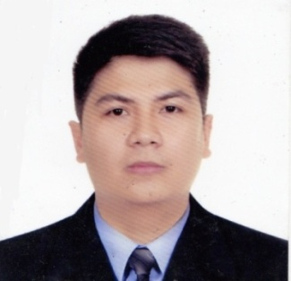

Glenmhore V. Galvez
PROFESSIONAL OBJECTIVE:

To succeed in an environment of growth and excellence and earn a job which provides me job satisfaction and self-development and help me achieve personal as well as organizational goals.

SUMMARY OF QUALIFICATIONS

- Experienced with excellent ability to multi-task while remaining highly detail oriented and
adaptable.
- Excellent in Customer Service.
- Highly motivated to achieve set goals.
- Well organized and focused in coordinating projects.
- Computer literate MS Word, Excel & PowerPoint.
- Highly enthusiastic individual who has a strong desire and commitment to achieve both personal and professional goals.

CAREER HISTORY

September 2014 – Present
DUBAI, U.A.E.

Crew Trainer (PROMOTED SINCE November 2015)
- Responsible for training our crew members for their day-to-day work serving customers, preparing food, keeping our restaurants and kitchens clean and tidy and working well as part of a team.
- Assess crew members' skills and offer them extra help with any tasks they may have problems with.
- Support and mentor crew members as they complete their own apprenticeship and guide the crew member through his or her development programmed.

Service Crew
- Provide customer service, assist in kitchen processes and generally ensure customers have an enjoyable dining experience
- Clearing off and setting tables, stocking supplies, cleaning dishes and occasionally dropping off food, beverages and condiments
- Kept records of the amount of food used
- Received payment for sold food items

November 2012 – January 2013 – GX International Inc.
Alabang, Muntinlupa City (PHIL.)

Sales Service Executive

- Promoting Medicine Products to Doctors.
- Visiting Clients as well as checking their orders.

- Presenting Samples to Clients for them to try the Products.
- Dealing with pharmacies to Represent our Products

September 2011 – March 2012 – Pizza Hut
Aurora Blvd. Quezon City (PHIL.)

Team Member

- Ensuring that there’s Customer Relation.
- Setting Tables and promoting the Limited Time Offers.
- Received payment for Sold Items

ACADEMIC QUALIFICATIONS

Tertiary 2007-2012

Polytechnic University of the Philippines
Sta. Mesa, Manila
Bachelor of Science in Biology

Secondary 2003-2007

Our Lady of Mt. Carmel College
Sabang, Baliwag, Bulacan

Primary 1997-2003

Maronquillo Elementary School
J. Valonda St., Maronquillo, San Rafael, Bulacan

PERSONAL INFORMATION

Birthday: Septemeber 22, 1990
Birthplace: Bulacan, Phil.
Nationality: Filipino
Language Spoken: English and Filipino
Personal Traits: Hardworking, Well Disciplined, Polite, Resourceful, Trustworthy, Organized, patient
And a swift learner

I hereby certify that the above information are true and correct to the best of my knowledge and belief.

Glenmhore V. Galvez

Glenmhore V. Galvez – 2014530
Whatsapp +971504753686
To interview this candidate, please send your company name, vacancy, and salary offered details along with this or other CV Reference Numbers that you may have short listed from http://www.gulfjobseeker.com/employer/cvdatabasepaid.php
addressing to HR Consultant on email: cvcontacts@gulfjobseekers.com
We will contact the candidate first to ensure their availability for your job
and send you the quotation for our HR Consulting Fees.

