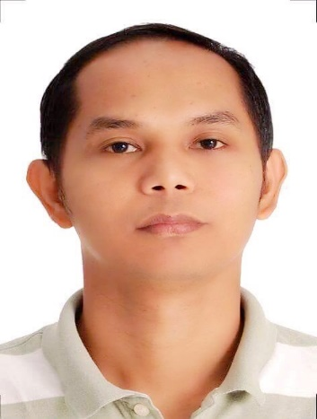
RYAN CAYAGO LAYNO
Dubai

WORKING EXPERIENCE
CAREER OBJECTIVE

To make a sound position in corporate world and work enthusiastically within a team to achieve goals of the organization with devotion and hard work.

Nov 11, 2014 to present
Call Center Agent – Customer Service/Technical Support Representative at Telstra Telecom Australia. Handle inbound and outbound calls, encode and update customers’ information, handle customer inquiries both telephonically and via email. Diagnose and resolve technical internet connectivity and email clients. Accurately process and record call transactions using a CRM (customer relation management) software. Offer alternative solutions where appropriate with the objective of retaining customers’ and clients’ business. Follow up and make scheduled call backs to customers.

- Convergys Philippines, Inc
Jan 11, 2011 to May 23, 2014
Call Center Agent – Customer Service/Technical Support Representative for USA and Canadian Dell & Microsoft Windows Customers/Business. Handle inbound and outbound calls, encode and update customers’ information, handle customer inquiries through phone and email. Provide computer hardware and software problem resolution. Trained as Sales Agent to sell hardware, software, services and warranty after or while troubleshooting. Deliver service and support to customers through phone, via remote connection or over the Internet. Follow standard processes and procedures. Accurately process and record call transactions using a computer and designated tracking software or CRM.

- KNA Computer Services
February 17, 2004 – November 3, 2010
Manager and Computer Technician. Manage the business, handles Repair & maintain computers, assemble computers, install hardware/software applications, Install network (wired/cabling and wireless connection), setup internet connection, Sell computers, and inventory. Hiring potential technicians and sales staffs. Responsible for effective sales strategies.

EDUCATIONAL ATTAINMENT

BS Computer Science
June 2001 – March 2003
AMA College
Quezon City, Philippines

Computer System Technician
October 1998 – October 2000
AMA Computer Learning Center
Quezon City, Philippines

PERSONAL BACKGROUND

Date of Birth : July 31, 1980
Place of Birth : Pangasinan, Philippines
Gender : Male
Civil Status : Married

CHARACTER REFERENCES

AVAILABLE UPON REQUEST

Ryan Layno

Ryan Layno – 2014590
Whatsapp +971504753686
To interview this candidate, please send your company name, vacancy, and salary offered details along with this or other CV Reference Numbers that you may have short listed from http://www.gulfjobseeker.com/employer/cvdatabasepaid.php
addressing to HR Consultant on email: cvcontacts@gulfjobseekers.com

We will contact the candidate first to ensure their availability for your job
and send you the quotation for our HR Consulting Fees.

