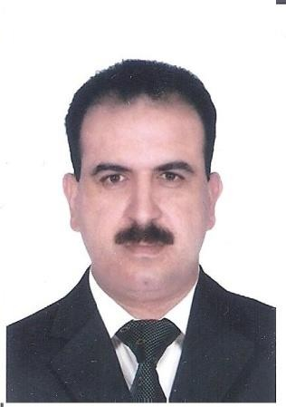Curriculum vitae

Maher
Maher.335802@2freemail.com

- OBJECTIVE:

To join a prestigious organization against a position with good chances of growth to benefit of both organization and myself through coordinating with a broad range of people including clients .peers and colleagues.

Personal information:

Date of birth : 21/03/1968

Gender : Male Maritial status : Married Religion : Muslim
Language known : Arabic ( mother tongue) English fluent
French fluent

Urdu basic

Visa status : UAE employment visa

Qualifications :

BA successfully graduated Tishreen University Syria - Lattakia

Diploma of French literature ( Arts , Literature )
Computer knowledge

- Well versed with ms office application
- Currently working on kerridge Autoline system
- Internet surfing.

Work experience :

1992-1998 : Teaching Arabic and French languages in Jules Jammal School and Teshreen
University in Lattakia Syria.
2001-2003 : Store keeper in Union co-operative society (food items)
2003 : Translator for French language with Dubai police( French Arabic-Arabic French)
passed a special certificate of appreciation from Dubai police.
2004-2005 : Translator for French language with New world entertainment( event organizer) company closed.
2006 -2016 : aAuto spare parts sales supervisor with Liberty Automobiles Company in Sharjah ,UAE regional dealer for Cadillac, Chevrolet , Hummer and Opel dealer for GM spare parts.

CURRENT POSITION:

Senior sales incharge

Key responsabilities :

< Meet& greet the customers and using the sales process to close the deal provided professional product knowledge implemented professional presentation and demonstration skill and consistently achieved monthly targets.

< Manage customer relationships to achieve sales goals

< Identifies and develops parts sales opportunities in all market segment and ensure customer satisfaction.

< Provide excellent standard of customer service as per company policies.

< Maintain customer database and close contact with customer to achieve and maintain the CSI.

< Solving the problems and the misunderstanding issues happened with the customers

< Ensure that customer orders are processed correctly and back ordered parts follow up and update to parts manager.

< Handling all warranty issues coming through retail counter.
< Registering all of loss sales and discussing it with ordering department

< Develop relationships to generate customer goodwill and loyalty by answering all questions in correct way ,understanding all customer needs .

Training attended (GM)

I have been passed about 50 different kind of training under GM instructors

- World of vehicles training
- Professional selling skill for parts consultants
- Epc4 training
- Microcat training
- Gm dat electronic parts cataloging
- Holden partfinder
- Effective telephone skills
- How to build customer enthusiasm
- Gm parts consultant training
- Building trust with service customers
- 2013 chevrolet Malibu parts introduction
- How to use vct
- Chevrolet brand introduction

