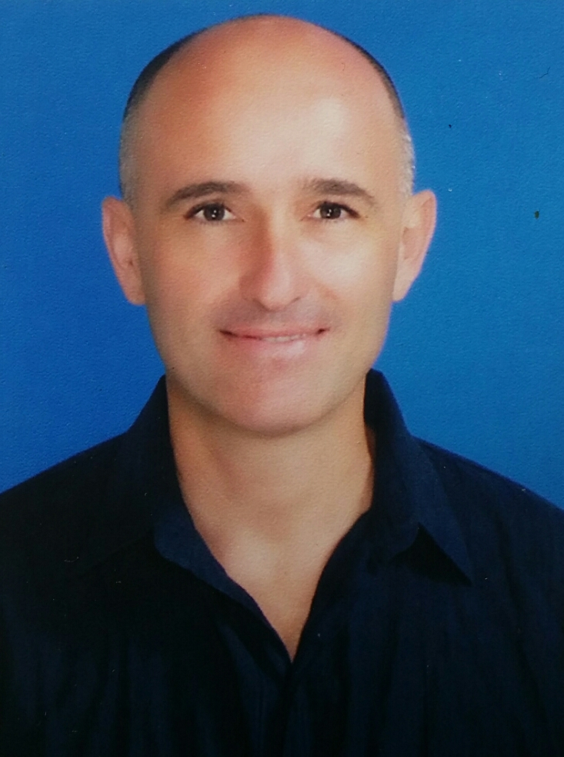
CURRICULUM VITAE
PERSONAL DETAILS:
Name: Pedro
Date of Birth: 16th August 1969

E-mail: Pedro.335855@2freemail.com

ACADEMIC RECORD:
University Education:

Postgraduate Studies:
- 2005-2006: Masters Degree in Psychology (Clinical and Health). University of Valencia, Spain.
- 2005-2006: Curso de Aptitud Pedagógia (CAP) – teacher training qualification. Equivalent of Postgraduate Diploma in Education. University of Valencia, Spain.

Undergraduate Studies:
- 1998-2003: Degree in Psychology. University of Valencia and Freie Universität Berlin, Germany (Erasmus year).
- 1992-1997: Certificates in English (5 years of study), German (5 years of study), French (3 years of study) and Italian (2 years of study) from Official Languages School, Valencia, Spain.

Other studies:
- 1995: Certificate in Entertainment – to organise and run activities for guests (children and adults) in holiday resorts.
- 2016: 160 Hours Masters Teaching English as a Foreign Language (TEFL) course

WORK EXPERIENCE:
- 2012-Present: Private psychological practice –focusing primarily on the areas of couples´ therapy, anxiety, phobias, adolescent issues and personal development.

- March-June 2011-2015: Tour guide - for various tour companies travelling throughout Spain and Europe. Organised tours to cultural destinations and accompanied large groups of guests for week long trips.

- 2005-2016: Chief entertainer - in La Penita Holiday Resort, Lanzarote. Planning, organising and running day and night activities for all guests (children and adults), Summer and Winter seasons.

- 2006-2011: Clinical psychologist in various settings:
- Secondary schools (´El Moli´ school Torrent, Spain and Instituto de Educacion Secundaria de Massassana, Spain). Working with students with behavioural difficulties and learning difficulties.
- Health centres (Centro de Salud de Catarroja, Spain). Providing all forms of psychological support for adults.
- Private practices in Torrent and Alcasser (Valencia, Spain) working with adults.
- Voluntary work as psychologist with a NGO.

- 2006-2008: Official tester for PISA (Programme for International Student Assessment) in various schools in the Community of Valencia.
Liaise with staff in a variety of secondary schools, carry out testing on groups of students and work in conjunction with testing company.

- 2007-2009: Teacher of English in adult school in Albal, Valencia – teaching English as an additional language to adults and teenagers. Preparing lessons, testing students and monitoring progress.

Skills:
- First Aid and CPR
- Qualified lifeguard
- Fluent in Spanish and German
- Advanced levels of English and French
- Intermediate level of Italian
- Touch typing
- Advanced IT skills

Interests:
- All sports
- Travelling
- Learning languages
- Experiencing new cultures
- Reading
- Current affairs
- Volunteering
- Scuba diving

References upon request

