CURRICULUM VITAE
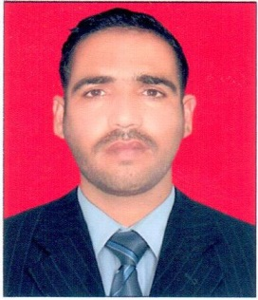
ASHIQ
Email : ashiq.335861@2freemail.com
DUBAI , U.A.E.
POST APPLIED FOR DRIVER

CAREER OBJECTIVE:
To work in a progressive and challenging environment where I can fully utilize the best of my skills, experience and hard work for the development of the company as well as the achieve growth in my career which have always been my forts in all the endeavors for the development of the organization and oneself.
PERSONAL INFORMATION
- Religion Islam
- Gender Male
- Nationality Pakistani
- Marital Status Married
- Date of Birth 25/03/1987
PASSPORT & VISA DETAIL
- Date of Issue 19/02/2016
- Date of Expiry 18/02/2021
- Visa Status Employment (release available)
LICENSE DETAIL
- Date of Issue 11/05/2010
- Date of Expiry 11/05/2020
- Place of Issue Dubai
- Category Heavy Bus (No.06)

ACADEMIC QUALIFICATION
- Secondary High school certificate in Pakistan
LANGUAGE DETAILS
- English, Urdu, Arabic
WORK EXPERIENCE
- 3 year as Heavy bus driver since 2013 to onward in AL-HURAIZ passenger Transport by rental –DUBAI AIRPORT
- 3 year as Heavy bus driver in AL-MARKHI GENERAL CONSTRUCTION L.L.C –DUBAI
CAREER SKILL AND KNOWLEDGE
- Having Valid Driving License Issued from UAE
- Having More than 6-7 Years of Experience in UAE
- Excellent Communication Skills
- Complete knowledge of UAE Roads and Locations
- Highly cooperative, responsible and team player
- Able to Learn Locations Very Fast
- Willing to work on multiple shifts
DECLARATION:
I hereby declare that the above statements are true and best of my knowledge and belief.
ASHIQ

