**Personal Profile**

I have a Higher Diploma in Personal Management & Company Law.

As I progress in my career path, I seek an opportunity in the field of Management in an

Area where I can apply the knowledge I have gained.

I strongly believe that I will be able to contribute to the Company with the knowledge

I have obtained from professional management qualifications, and the work experience

I have gained through my career path.

**Professional Qualifications**

Gained 35 years’ experience in both clerical and Administration duties.

03 years Gulf experience in administrative work.

Experienced in routine office administration duties.

Good English in spoken & written.

Having strong sense of responsibilities.

**Academic Qualifications**

Passed General certificate of examination Ordinary level.

Passed General certificate of examination Advance level.

Obtained Higher Diploma in Personal Management.

Obtained a Diploma in Company & Business Law.

**PALITHA**

Email: [palitha.335871@2freemail.com](mailto:palitha.335871@2freemail.com)

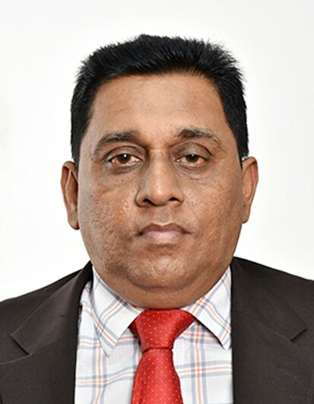

Date of Birth : 1957.12.06

Gender : Male

Civil Status : Married

Nationality : Sri Lankan

School Attended :

Isipathana College

Colombo 07

**Professional Experience**

1. **Company name :**
2. Riyadh City Cleaning Project

Kingdom of Saudi Arabia

Period of work : August 1990 – August 1994

Position : Personal Assistant

Duties & Responsibilities:

* + Clerical & Administrative work
  + Industrial relation work
  + Maintaining Employees personal files
  + Maintaining Leave records

1. **Company name : Readyware Industries Ltd**

Company profile : One of the leading Garment Export companies in Sri Lanka

Period of work : September 1993 – February 2003

Position : Clerical Officer

1. **Company name : TVS Lanka Pvt Ltd (United Motors Pvt Ltd)**

Sri Lanka

Period of work : May 2004 – May 2010

Position : Logistic Assistant

* Identify product improvement or new product by remaining current on industry trends, market activities and competitors.
* Prepare reports by collecting, analysing and summarizing information.
* Helping relationship formed between a client who has managerial authority and responsibility in an organization and a consultant who uses a wide variety of behavioural techniques and methods to assist the client achieve a mutually identified set of goals to improve his or her professional performance and personal satisfaction and consequently to improve the effectiveness of the client's organization within a formally defined coaching agreement."
* Promotion of the GEMS brand to professional networks and organisations.
* Handling the company website (Cresla website, Turbo Lister, Shopping Cart, eBay)

**PALITHA**

Personal Attributes:

* Dedication
* Team Player
* Leadership
* Self-Motivated
* Innovative

Strengths:

* Flexibility
* Time Management
* Higher level of commitment

Towards achieving goals

* Ability to deal with different

Personality traits

* Ability to work under

Pressure