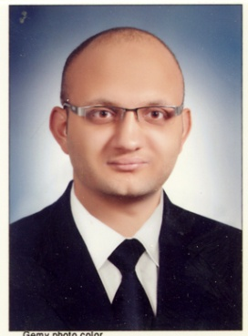
Mohamed
Mohamed.335888@2freemail.com

OBJECTIVE
My objective is to join a team in a rapidly growing company where I would be challenged and given the opportunity to enhance my skills, experience& performance to the benefit of the company, gaining importance & developing my career within that company.
PERSONAL DATA
Nationality: Egyptian.
Marital status: Single.
Military Status: completed.
Date of Birth : 19/11/1988 .
EDUCATION
B.SC of pharmaceutical studies 2011 Faculty of pharmacy-Helwan University.
Grade: Good (71%) .
CAREER RELATED EXPERIENCE

- Joined boehringer ingelheim as medical sales representative for Micardis (cvs line) from JUNE 2015 till now at 6 ocober, Cairo , Egypt .
I achieved 105 % at 2016 sales vs target .
Have Lunched new combination Twynsta achieved 101 %
Semester 1 .
Outcome experience : lunch new product .
- Joined Astrazeneca as sales representative for Nexium (Git line) since novamber 2013 till June 2015 .
I was responsible for promoting nexium vial and tablet in two of top ten tenders in Egypt .
I achieved 109 % sales vs target in 2014 and 100 % in semester of 2015 .
I had been recognized as best successful story and best trend in term of incremental increase of sales .

Outcome experience : promotion of drug for acute diseases , governmental , private tender and hospital business .

- Med rep (part time) for Mash premire during my military service from april to aug 2012.
- EL-baklawy pharmacies (ramsis branch) during my military service (2012) .
- Pharmacist at Air Force hospital (2012/2013) .
- Training course in 57357 hospital (2010) .

COURSES
- Student skills development program (SSDP) of RTC in cairo university (2007) .
- Clinical pharmacology diploma of international cultural center (I.C.C) (2008) .
SKILLS
Computer Skills: Internet Applications
- Language Skills: Arabic: Mother tongue. English: Very good.
ACTIVITIES
- Active member in Egyptian pharmaceutical students federation (EPSF-Helwan) .

