CURRICULUM VITAE
Mr. Muhammad
Muhammad.335908@2freemail.com
IDENTIFICATION:
Name: Muhammad 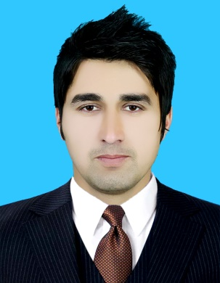
Date of Birth: 07th August 1994
Sex: Male
Nationality: Pakistani :
City : Peshawar
Country : Pakistan
ACADEMIC QUALIFICATION:
Degree | Session | Institution | Grade | Marks
Ms.c | 2014-2016 | University of kohat | 3.24 out of 4 | 3.24 out of 4
BS.c | 2014 | University of Malakand | B | 381/550
Higher Secondary School Certificate (F.Sc) | 2012 | BISE Malakand | A | 803/1100
Secondary School Certificate (Matric) | 2010 | BISE Malakand | A | 801/1050

TITLE OF MS.C THESIS:
“Gas filled detectors”
Teaching EXPERIENCE:
- One year teaching experience at school level.
- One year teaching experience at college level.
SKILLS AND CAPABILITIES:
Demonstrate sound written, verbal and presentation skills.
Possess good inter-personnel, leadership and analytical skills.
Ability to take initiatives and accept challenges.
Self-motivated and enthusiast
LANGUAGE SKILLS:
Language | Read | Write | Speak | Understand
English | Fluent | Fluent | Fluent | Fluent
Urdu | Fluent | Fluent | Fluent | Fluent
Pashto | Fluent | Fluent | Fluent | Fluent
I.T Skills:
Expert in MS Office.
Well familiar with Internet Browsing.

