Bijitha
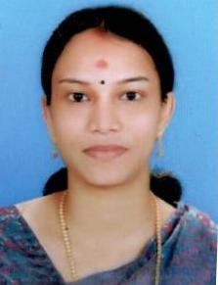
Bijitha.335925@2freemail.com

Objective: To acquire a challenging position that would best fit my qualifications and be a part of a team wherein I can enhance and apply the knowledge I have learned through actual application, which will indulge professional growth and rewarding career.

WORK EXPERIENCE

Worked as Guest Lecturer in Physics at Government College Kasargod.

DUTIES & RESPONSIBILITIES

- Evaluate and grade students classwork, laboratory work, assignments and papers.
- Prepare and deliver lectures to graduated students on topics such as photonics, electricity and magnetism, thermal physics, etc.
- Maintain students attendance records, grades and other required records.
- Supervise students laboratory work.
- Prepare course materials such as syllabi, homework assignments and handouts.
- Maintain regularly scheduled office hours in order to advise and assist students.
- Initiate, facilitate and moderate classroom discussions.
- Select and obtain materials and supplies such as textbooks and laboratory equipments.
- Participate in campus and community events.

EDUCATION

- SSLC March 2003 88.68% GHSS Udinur
- Plus Two March 2005 80.17% GHSS Udinur
- B.Sc. (Physics) March 2008 71.2% Nehru Arts of Science College
Kannur University

- M.Sc. (1st Rank Holder) May 2010 83.1% Annamalai University
- B. Ed. October 2011 59.3% Jaybees Training College of Bed
Kannur University

*** Secured First Rank in the MSc (Physics) Degree Examinations and has been awarded a medal from Tamilnadu Governor at the Convocation.

STRENGTHS

- Has knowledge in using Microsoft Word, Microsoft Excel, Microsoft PowerPoint
- Knowledgeable in Programming with CC++

PERSONAL INFORMATION

Date of Birth: February 28, 1988
Marital Status: Married
Gender: Female
Nationality: Indian

