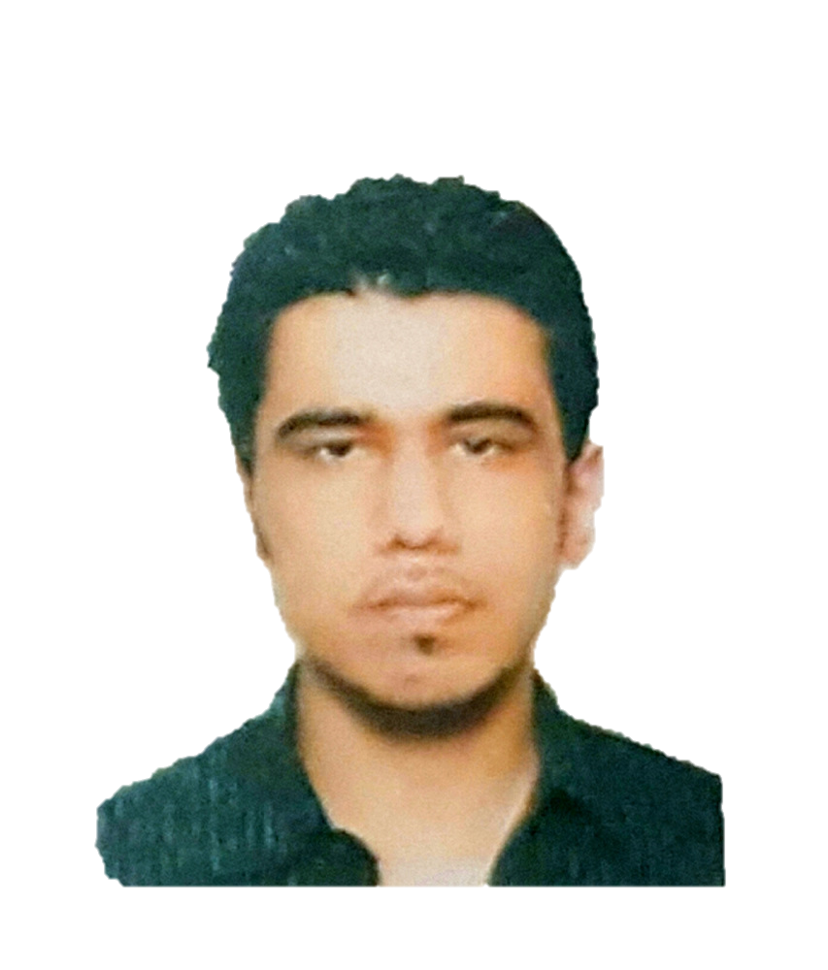
Mustafa
Mustafa.335973@2freemail.com

JOB OBJECTIVE

My job objective is to employ my skills and talents that I have acquired with my experience along with my education to contribute to an organization that creates true value for its members and its customers that provides me a platform to learn and grow.

EDUCATION

2013- 2016 Murdoch University Dubai, United Arab Emirates
Bachelors of Science
Major Business Information Systems

2007-2009 The Winchester School (GEMS) Dubai, United Arab Emirates
IGCSE, 0-Levels
High School

WORK EXPERIENCE

2010-2013 GAPCO Trading Dubai, UAE

IT Technician (Operations & Support)

- Performed daily system monitoring, verified the availability of all hardware and software resources.
- Performed regular backups of files and stored on multiple platforms.
- Ensuring no security protocols were breached by keeping WPA2 security on the company’s network.
- Repaired and recovered systems from hardware or software after investigating the issue.
- Applied regular updates to systems software, such as OS upgrades and client software upgrades.
- Kept the organization’s network safe from intrusion by configuring firewalls and encrypting the network.
- Applied hardware upgrades, such as installing new Hard-drives and replacing older parts to maintain efficiency.

RELEVANT PROJECTS

- Created a Business plan using BPMN notation for an Event Management company (2014)
- Information Technology Project, Murdoch University Dubai (2016)

PROFESSIONAL SKILLS
- Strong decision-making skills; Critical thinking.
- Motivated to work in teams and focused on team performance.
- Strong time management skills and meeting deadlines in advance.
- Ability to manage multiple-tasks; Capacity to prioritize tasks and work under pressure.
- Strong organizational skills; decision making and problem solving.
- Designed systems mapping and Business process diagrams (BPMN).
- Ability to work with Systems Databases and MySQL.
- Excellent knowledge of HTML and CSS, and basic understanding of C# and Java.
- Ability to create and manage websites.
- Working with Knowledge Management techniques and Metadata.
- Moderate understanding of Systems Networking, IPs and Server’s management.
- Knowledge in Cloud Systems, such as Azure Cloud Server and Microsoft SharePoint.
- Strong oral and written communication skills.
- Ability to liaise well with others and delegate tasks.
- Flexible and adaptable to changing workloads.
- Ability to work with the following platforms:
    - Microsoft Visual Studio
    - Microsoft Excel
    - Visual Paradigm
    - Microsoft Visio
    - Microsoft Project
    - Microsoft Office
    - Protégé
    - Adobe Dreamweaver
    - Adobe Illustrator
    - Adobe Photoshop
    - Sony Sound Forge
    - WordPress
    - Microsoft Azure

LANGUAGES: English (Fluent)
Urdu

PERSONAL DETAILS

Visa Status: UAE RESIDENCE VISA & EMIRATES ID
Driver’s License: DUBAI

REFERNCES AVAILABLE ON REQUEST

