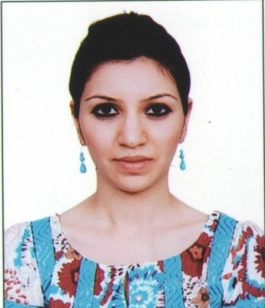
RESUME

Bio Data:

Name: Anum
Anum.335992@2freemail.com

Aims & Objectives

Seeking an opportunity to work in a well reputed organization and excel in the field of Marketing & H.R and to enhance my knowledge and capabilities by accepting new challenges.

Work Experience

Self Employed (Fashion Designing) – Designer of custom – made women’s apparel for day wear and special occasions

Qualifications

Qualification | Majors | Year | Institution
Masters | Economics | 2012 | Karachi University
Bachelors in Arts | Economics, International Relation | 2009 | Karachi University
Intermediate | Arts | 2006 | Degree College for Women (DHA)
Matriculation | Science | 2004 | Army Public School
SKILLS & INTERESTS

Capable of managing Social Media
Innovative in developing business strategies
Interested in reading, social networking, and event planning
Personality Traits

Honest
Charismatic
Hard working

