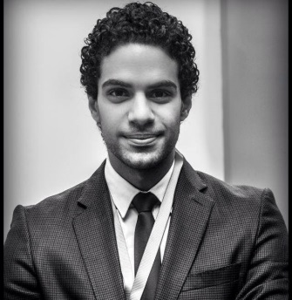
MAHMOUD
MAHMOUD.335993@2freemail.com

CAREER OBJECTIVES:

Is to acquire good position in a multinational organization and be a part of successful team, keep the organization in competition and built good career by reaching respectable position through fulfilling tasks demanded professionally.

PERSONAL DETAILS:

Date of Birth: 18th of August 1989
Nationality: Egyptian
Marital Status: Single
Visa Status: Employment Visa

EDUCATIONAL ATTAINMENT:

UNIVERSITY: ARAB ACADEMY FOR SCIENCE, TECHNOLOGY AND MARITIME TRANSPORT
COURSE: BACHELOR DEGREE IN TRADE LOGISTICS & INTERNATIONAL TRANSPORT MANAGEMENT (GPA 3.2) very good
YEAR: 2006 TO 2010

PROFESSIONAL EXPERIENCE:

2016 Of May till present
Marina Albateen Resort Health Club
Receptionist

2015 of October to April
ET Logistics
Operation & Sales

2014 of August to 2015 of February
Etisalat International
Call Center

2013 of July to 2014 of July
Al Tayar Shipping & Customs Clearance
Operation, Import & Export

2011 of December to 2013 of June
Allianz Life Insurance Co.
Sales out Door

2011 of December to 2010 of October
Hours Shipping & Transport (AFG Logistics) Co.
Freight forwarding at operation department

COURSES:

Transport & Logistics Modeling, | Quality Management,
Chartering Management, | Inland Transport Management,
Multimodal Transport, | Navel Architecture,
Risk & Insurance Management, | Human Resources Management,
Operations Research, | Accounting (Financial, cost, Managerial),
Freight Forwarding Business, | Cargo Handling Management.
Supply Chain Management, | Logistics Operation Management

SKILLS:

- Ability to work well under pressure – was able to handle the University schedule of examinations & assignments and Family Business (Cattle farm). Excellent communication,
- Excellent communication, interpersonal and presentation skills (developed through presenting class assignments and working with colleagues on projects).
- Very Good knowledge of MS Office (including Excel) and good knowledge of MS Access Database.

LANGUAGES:

- Arabic (Native Language)
- English (Very Good written & Spoken)

EXTRA ACTIVITIES:

- Responsible of planning & leading annual purchasing & Distribution of clothing & food to those in need people in rural areas.

- Member of ITLC (International Transport & Logistics Club) attended self-improvement classes (a better you – how to handle first job).

- Member of SIFE (Students in Free Enterprise) Involved in charity activities including helping in need areas and supply them with food and clothing.

PERSONAL CHARACTERISTICS:

- Highly motivated
- Pleasant Personality
- Cheerful and Hardworking

HOBBIES:

- Swimming
- Football
- Water ball

REFERENCES:

All available when needed.

