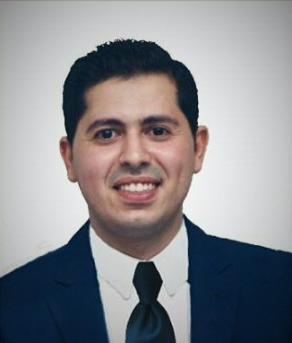
Mohamed
Mohamed.335997@2freemail.com

Career Objective:
I'm fully enthusiastic to take a new challenge in my career to work for a reputable progressive organization with a healthy atmosphere and clear career pathway that will effectively utilize my skills and commitment to perform quality work.

Personal Information:
- Date of birth:August13, 1990.
- Nationality: Egyptian.
- Marital status:Married.
- Egyptian driving license: Valid.
- UAE driving license :Ready to Rent a car with driver during work hours and
Attend VIP driving lessons to gain License within 2 weeks

Education:
- June 2012:Alexandria University, Egypt.
Bachelor's degree in pharmacy and drug
Manufacture (2007-2012)
Grade:Verygood.
Career Experience:
- July 2014 – November 2016Medical Representative at Abbott Laboratories.
- Assignments :

    - Responsible for Cardio Metabolicbusiness unit.
    - Responsible for promoting Lipanthyl, Isoptin, Rytmonorm and Tarka.
    - Responsible for increasing the awareness of Abbott products & image.
    - Provide regular plans, reports & updated customers list.
    - Follow up with distributer to insure stocks and follow up sales.
    - Responsible for sales in private and government sectors.
- Achievements:
    - Awarded as a best achiever in Cardio Metabolic Line (Alexandria team), 2015.

- March 2014Al-Amana Pharmacy, Egypt.
- Summer 2012 Abo-Zyada Pharmacy group, Alexandria, Egypt.
- Summer 2011 Medical representative traineeat "PHARCO Group"

Related coursesand Training:
- May 2014140 training hours as "selling skills"
certified by SEDICO.

- April 2012"Patient Counseling" course certified by
Faculty of Pharmacy, Alexandria University.

- January 2012General English course at British Academy(level 12).

- November 2011 ICDLcertification form Alexandria University.

- July 201175 training hours as " ManagerialApproach"
in"Pathways to Higher Education – Egypt " project.
- November 200936 training hours as "Soft Skills Training Program"
atInformation Technology Institute.

Skills:
SkillSkill level
- Microsoft Application (Windows, Office & Internet) very good
- Presentation skills excellent
- Communication skills excellent
- Negotiation skill very good
- New techniques, creative ideas for problem solving excellent
- Ability for working in team & under stress excellent

Language:
- Arabic: Native language.
- English: Excellent.

Personal General Interests:
- Learning & knowing much more.
- Internet Browsing & Searching.
- Playing Football & Reading.

Note:All references will be available upon request

Thank you

