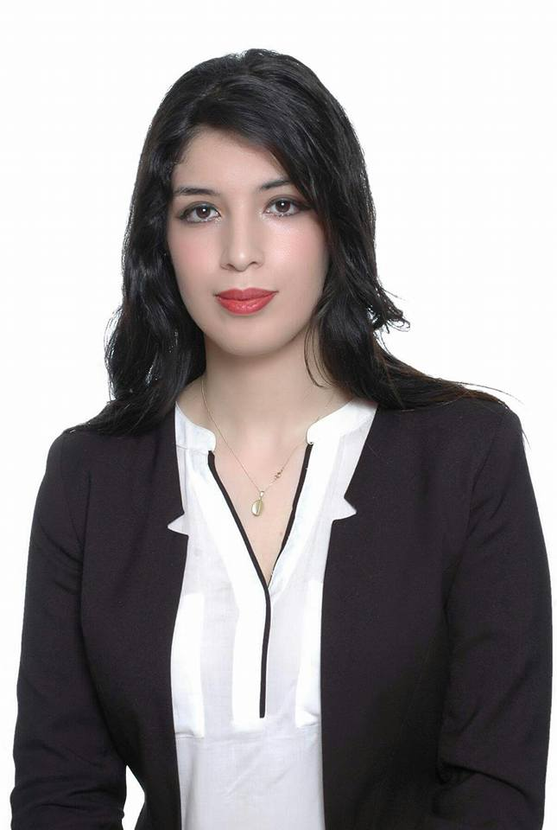
Soukaina
Soukaina.336016@2freemail.com

Experience
Maximum 3 compétences.
Cette rubrique peut remplacée par objectifs.

- 2015 / 2016 Golden vert maroc, Personal assistant

- Planned the time table schedule of business,personal and weekend activities
- Efficientely managed telephone calls and emails
- Maintained and managed activities commitements, and deliveries
- Prepare agendas for meetings
- Organized personal and professional calendars
- Advanced knowledge using Microsoft Office : MSWord, MSOutlook and other software programs

Education

- 2015 Bachelor degree in English studies
Sidi mohamed ben abdallah. Fes

Languages

- Arabic
- English
- Frensh
- Hindi

Areas of expertise

- Accurate and detailed

- Analysing problems

- Reliability

- Excellent communication skills

- Administrative support specialist

