c

URRICULUM
v
ITAE
Waqar
Waqar.336029@2freemail.com 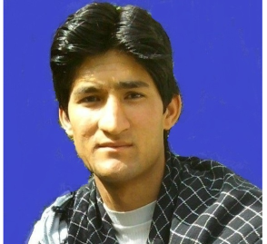
OBJECTIVE
My career objective is to acquire a challenging position in the any field. Key strengths are my ability as team worker and my innovative ideas of thinking to be different. I want to work in dynamic environment and to use my abilities and utilize my knowledge, skill and experience in the field.
PERSONAL INFORMATION
Date of Birth : 16 October 1990

Gender : Male

Domicile : Neelum

Nationality : PAKISTANI
ACADEMIC QUALIFICATION
DEGREE | BOARD/ UNIVERSITY
1-MS(M phil )Software engineering | ABASYN UNIVERSITY ISLAMABAD
2-BS Software Engineering | University of Azad Jammu & Kashmir.
3-F.SC | BISE MIRPUR (Model science college Muzaffarabad).
4-Matriculation | BISE MIRPUR (Govt. Boys High school Nagder).

- Other Skills
- Communication Skills
- Presentation Skills.
- Languages (C, C++, C#, Java,Html,Dreamweaver,Wordpress).
- Database (Access, MYSQL and SQL Server).
- Microsoft Windows Operating Systems (98-2000-XP-7-8).
- Microsoft Office (97- XP- Present-10).
- Installation of Hardware and Software.
- Internet working & Browsing.

Work experience
- Three years teaching experience
- Presently working as a computer instructor BPS 17 in Government High School Neelum AJK
- Total work experience 5 years

INTEREST
- Visiting & Travelling.
- Playing games
- Commentary on live cricket matches
- Playing cricket
- Reading Newspapers,Watching Movies.

AIM IN LIFE
Being an efficient employer and enhance own activities, working honestly, doing best efforts in benefit of employers and institutes, Working for a prosperous society.

REFERENCES
Will be provided on demand.
I slomleny declare that all above mentioed informaitoin is correct.

