UMAR
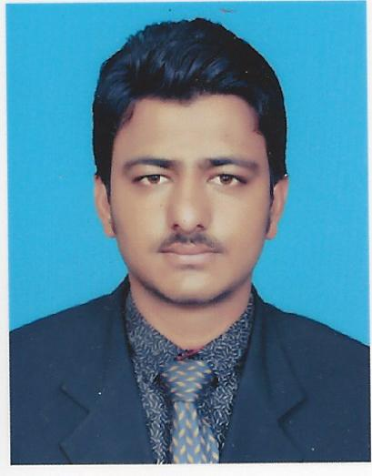
UMAR.336084@2freemail.com

Curriculum Vitae

PROFILE

I am highly motivated individual with a keen eye for detail. I am looking for an opportunity to prove my worth and advance my career as far as possible. I consider myself to be an effective team player with excellent leadership skills.

I believe given a chance I would become an asset to my company immediately.

CAREER EXPERIENCE

- Worked as (Civil,Auto Cad 2D+3D) in Master Mind Architect Office,Bhimber,Pakistan (2013 to 2015).
- Worked as teacher (Civil,Auto Cad) in Master Mind School ,Bhimber (2014 to 2015).
- Working as a Safety officer (HSE) in Bahria Town, Islamabad (Housing & Road Project of International Standard (2015 To 2016)
- Work at BMG False Ceiling, Dubai-UAE (2016 – Present)

PERSONAL INFORMATION

- Language : Urdu and English
- Nationality : Pakistani
- Date of birth : 20/08/1992
- Place of birth : Bhimber
- Marital status : Single
- Health : Good

EDUCATION

- D.A.E ,Diploma Of Associate Engineer (Architecture & Civil)
- Matriculation
- Safety Officer (IOSH and HABC)

CAREER OBJECTIVE

- A mid-level position with an opportunity for growth and advancement within the scope of my studies or other related fields.

SKILLS AND ABILITIES

- Have a good experience in construction Field.
- Have a good ability to think drawings.
- Excellent ability to work under pressure.
- Excellent computer knowledge.
- High problem solving ability.
- Work very well independently or with a team.
- Self motivation.
- Study desire.

REFERENCES

Available upon request.

