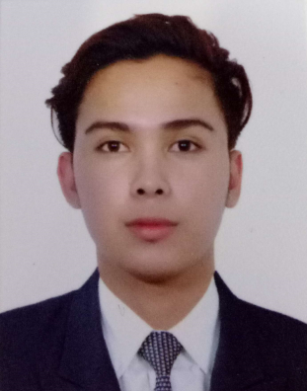
RAYMART
RAYMART.336087@2freemail.com

■ Objective – Obtain a position as customer service representative, where my customer relations experience can be fully utilized to improve customer satisfaction and promote the company’s brand name.

Skills and Qualifications:
- Problem Analysis
- Problem Solving
- Organizational Skills
- Customer Service Orientation
- Adaptability and initiative towards work
- Knowledge of handling customer issues
- Ability to work under pressure – Time management
- Outstanding communication skills – To interact both with clients and cross-company workers.

Work Experience/Background:
Microsoft Partner Network Cloud Services Support (September 2015 – January 2017)
Arvato Bertelsmann
Customer Service Representative
Clark, Philippines
- Interact with engineers from leading technology companies around the world.
- Field and manage technical customer issues via phone, chat and email.
- Apply advanced troubleshooting techniques to provide unique solutions to our customers' individual needs.
- Leverage your day-to-day experiences to provide the voice of the customer to internal support teams.
- Drive customer communication during critical events.
- Send email tutorials, how-to videos, and other technical articles for the customer.
- Trained and coached team members to deliver a high standard of customer service.
- Learned about products and services and kept up to date with changes.

Microsoft - Partner Technical Router (PTR) (January 2015 – September 2015)
Arvato Bertelsmann
Customer Service Representative
Clark, Philippines
- Communicating directly with customers by phone or email.
- Provided customers with technical support using maintenance procedures created with company products.
- Wrote and kept accurate records of discussions and correspondence with customers.
- Managed and supervised a team of customer services representatives.
Capital One Auto Finance - Inbound Collections November (2013– January 2015)
iQorPhilippines
Customer Service Representative
Clark, Philippines
- Responded promptly and answered/resolved customer inquiries and complaints.
- Investigated and resolved service issues and/or product problems.
- Managed customers’ database accounts, performed customer verification and processed payments, inquiries and requests.
- Worked with administration: forwarded requests and unresolved issues to the designated resource by communicating and coordinating with internal departments.
- Kept records of customer interactions and actions taken, including – transactions, comments, inquiries and complaints.
Purchasing Power, 1800 Flowers, Haband (September 2012 – November 2013)
Cyber City Teleservices/ iQor 3
Sales and Customer Service Representative
Clark, Philippines
OJT – On-the-Job Training
- Assisted customers with their queries and problems by phone and e-mail.
- Established and maintained contacts with new and existing customers as per the direction of the supervisor.
- Helped customers place new orders easily.
- Forwarded important and serious matters to the seniors.
- Transferred urgent calls to the required departments quickly and accurately.
- Entered and updated new customer details in the customer relationship management software according to administrative guidelines.

Educational Attainment:

- Information Technology and ComTech (2 years)
Intercontinental School of business and Information Technology
3rd Floor Sawali Bldg., Plaza Burgos, Guagua, Pampanga
S.Y: 2012 – 2013

- Guillermo D. Mendoza High School
Sta. Filomena, Guagua, Pampanga
S.Y: 2010 – 2011

- Bancal Elementary School
Bancal, Guagua, Pampanga
S.Y: 2006 – 2007

