CURRICULUM VITAE

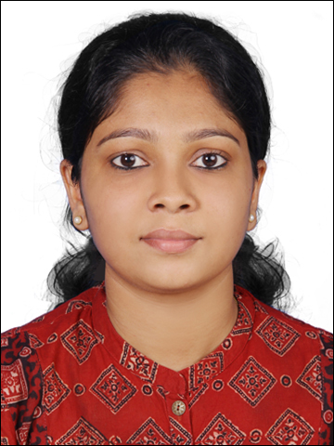
SILPA (HAAD RN LICENSED)
UNITED ARAB EMIRATES
SILPA.336116@2freemail.com

PROFILE
AGE : 25 yrs.
SEX : Female
D.O.B : 11/05/1990
MARITAL STATUS : Single
NATIONALITY : Indian
LANGUAGES KNOWN : English, Malayalam, Kannada, Hindi

OBJECTIVES

I aspire to take a challenging position and be a part of your team and want to make it efficient and winning. Want to serve in your organization, which offers challenging tasks and where constant up-gradation of knowledge is possible.

TECHNICAL SKILLS

- Operating Systems : MS Windows XP
- Application software : MS office (MS-Word, MS-PowerPoint, MS-Excel)
- SAP

POST

MEDICAL SURGICAL WARD
SUMMARY OF QUALIFICATION
- Strive to understand patients need and requirements and act promptly to achieve their needs.
- Hardworking and energetic; flexible; adapt easily to change of environment and work schedule.
- Maintain critical thinking skills essential to providing competent and dignified patient care.
- Personable with a positive attitude; interface well with patients, families, and nursing staff.
- Polite and dedicated staff with high tolerance and patience level.
- Good communication skill can communicate with people in English, Hindi, Malayalam and Kannada.

ACADEMIC QUALIFICATION

QUALIFICATION | INSTITUTION/BOARD | YEAR | PERCENTAGE SCORED
SECONDARY SCHOOL LEAVING CERTIFICATE | INFANT JESUS ENGLISH MEDIUM SCHOOL,THIRUVAMBADY | 2005-2006 | 88%
PRE UNIVERSITY COURSE | SACRED HEART HIGHER SECONDARY SCHOOL,THIRUVAMBADY | 2006-2008 | 87 %
BSc IN NURSING | NATIONAL INSTITUTE OF MENTAL HEALTH AND NEURO SCIENCES, BENGALURU. | 2009-2013 | 69%

PROFESSIONAL EXPERIENCE

INSTITUTION | PERIOD | DESIGNATION | NATURE OF WORK
SIR H N RELIANCE FOUNDATION HOSPITAL, MUMBAI | 16 DEC 2013 TO 30 JUL 2016 | OFFICER NURSE | MEDICAL SURGICAL WARD

A Mukesh Ambani venture.Paperless hospital in India which follows the standards of John Hopkins Hospital, USA. On the process and assessment of NABH and JCI Accreditation.

REGISTRATION DETAILS

NURSING REGISTRATION BACHELOR OF DEGREE | NURSE REGISTRATION NUMBER
KARNATAKA STATE NURSING COUNCIL

MAHARASHTRA NURSING COUNCIL

EXPERIENCE AS A OFFICER NURSE IN MEDICAL-SURGICAL WARD

- Provide direct care for adult and geriatric patients with medical and surgical conditions.
- Provide pre-operative and post-operative care for the patients.
- Skill to assist doctors in various procedures like endotracheal intubation and central line insertion, arterial line insertion, biopsies, abdominal paracentesis, lumbar puncture.
- Skill to follow all basic nursing care with initial assessment of patient.
- Skill to give CPR effectively in case of cardiac arrest.
- Skill to operate defibrillator and give shock to cardiac arrest patients as per doctor’s order.
- Preparing and administering medications and IV fluids.
- Administer blood and blood products.
- Skill to give care to patients on ventilator support.
- Skill to communicate effectively to the clients and participate with their clinical assessments.
- Skill to develop care plans to assist the patient care and implement them on an evidence based approach.
- Skill to liaise with other multidisciplinary teams regarding the care plan and evaluate the progress of client care needs.

EQUIPMENTS AND PROCEDURES

- Oxygen Administration, Wound Dressing
- Suction Apparatus And Suctioning
- ECG Machine
- Cardiac Monitor
- Nebulization
- Pulse Oximetry
- Infusion Pump & Syringe Pump
- IV Cannulation
- Ventilator Monitoring
- Collection Of Specimen
- Catheterization

ADDITIONAL QUALIFICATION

PASSED HAAD RN EXAM (

CERTIFICATION

- BASIC LIFE SUPPORT (BLS)

DECLARATION
I hereby declare that above mentioned information is true to my knowledge and belief. I bear the responsibility for the correctness of above-mentioned particulars

