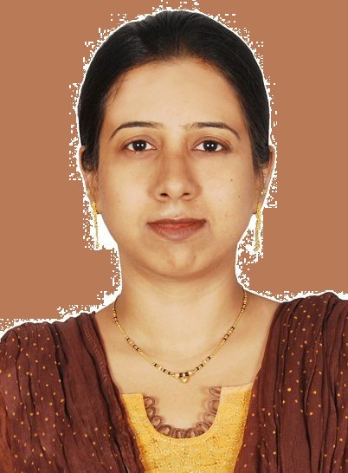

Farhat Rajnagarwala

________________________________________________________________________

Summary

- A resourceful and committed MBA looking for a challenging career where I can explore my ability and enhance my technical skills
- Expertise in MS office (especially ms excel)
- Strong mathematical background and numerical aptitude
- Good experience in handling customers, giving them advice regarding investments and other benefits and liasoning with the officials
- An imaginative, intelligent and proactive team worker with good interpersonal skills

Work Experience
Web Analyst (May 2014 – November 2014)

Duties & Responsibilities

- Checking various medical products available with manufacturer or vendor and then uploading them on the website online.
- Advertising and uploading products and product-related information on websites like amazon, sears, ebay etc.
- Taking orders from the customers, data entry, billing and pricing of products.
- Exploring new websites for more health products available.

Assistant Manager, The Udaipur Urban Co-operative Bank Ltd. (April 2008 – June 2011)

The Udaipur Urban Co-operative Bank is one of the leading banks in co-operative sector.

Duties & Responsibilities

- Opening and managing Saving Bank Account, Recurring Deposits, passing of cheques, issuing Demand Drafts as well as purchasing Drafts from other Banks.
- Issuing Payorders and checking and tallying balances every weekend.
- Keeping record of Stationery used, issuing of Cheque Books, pass books etc.
- Checking Detail Books & Day Books everyday.

Bolt Operator, Noble Finvest (Nov. 2007 – April 2008)

Noble Finvest is a Franchisee of share broker and agent “Bonanza Portfolio Ltd.”
and deals in shares and securities trading.

Duties & Responsibilities

- Opening of DP Accounts and trading accounts.
- Share trading for customers (sale and purchase of shares and securities on customer’s behalf and charging brokerage and commission for the same)
- Checking daily positions of the clients as well as giving them valuable advice regarding purchase of securities, investments in IPOs etc.

Web Analyst, Quaisar Medisoft Pvt. Ltd. (May 2007 – Sept. 2007)

Quaisar Medisoft is a US-based company which deals in medical equipments
like hospital beds, accessories, crutches, wheel chairs etc. It is a kind of BPO. Everything is done on-line. The physical goods are available in US and are supplied to the customers present there. Only back-office work is done in the office.

Duties & Responsibilities

- Advertising and uploading products and product-related information on websites like amazon.
- Taking orders from the customers, data entry,billing and pricing of products.

Training

Prudential ICICI Mutual Fund (Jan 2007 – May 2007)
Prudential ICICI Mutual Fund is an AMC dealing in mutual funds.

Duties & Responsibilities
Direct Selling of mutual funds and related products to clients, giving leads of the clients as well as managing and providing better services to the clients including advice related to savings and investments.

Academic Record

Postgraduate
Master of Business Administration, 2007
Specialization : Service Sector Management (Banking & Finance)
College/University : Faculty of Management Studies, MLSU

Graduation
Bachelor of Commerce
College/University : Bhopal Nobles Girls College, MLSU 2005

XII : The Study School (CBSE) 2002

X : The Study School (CBSE) 2000

Personal Data

Husband’s Name: Mr Asif Iqbal Rajnagarwala
Date of Birth : 21 July,1984
Sex : Female
Nationality : Indian

Marital Status : Married
Languages : English & Hindi
Visa : Husbands Visa

Farhat Rajnagarwala – 2016762
Whatsapp +971504753686
To interview this candidate, please send your company name, vacancy, and salary offered details along with this or other CV Reference Numbers that you may have short listed from http://www.gulfjobseeker.com/employer/cvdatabasepaid.php
addressing to HR Consultant on email: cvcontacts@gulfjobseekers.com

We will contact the candidate first to ensure their availability for your job
and send you the quotation for our HR Consulting Fees.

