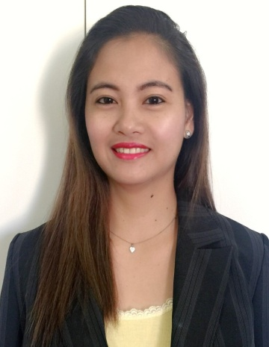
Gladys
Gladys.336132@2freemail.com

KEY QUALIFICATIONS
- With high degree of initiative, flexibility and resourcefulness with a drive for efficient results
- Excellent interpersonal skills, ability to establish and maintain excellent work relations in a team environment
- Excellent time management skills, ability to prioritize assignment, and work effectively under pressure with minimum supervision
- Excellent written and verbal communication skills in English
- Proficient in MS Office and Internet usage

WORK EXPERIENCES
- Personal Asisstant
for Jowaher Bnt Abdulaziz Bn Salman Al Saud
Princes of Kingdom of Saudi Arabia
(September 2013 to October 2015)

- Organizes and maintains diaries and appointments
- Arranges travel, visas, accommodation and itineraries
- Plans and supervises (with internal and external staff or agents) events
- Deals with suppliers, other staff members, visitors and clients
- Makes personal background research for individual presentation during briefings
- Assists and accommodates VIP

- Receptionist / Waitress
Greenbelt Lounge
Dubai, U.A.E
(March 2012 to July 2012)

- Maintains the highest quality and consistency of product and service standards
- Greets all customers with fast, friendly, personalized service and develops rapport by learning and acknowledging their names, favourite drinks and food items
- Describe menu items to customers or suggest products that might appeal to them.
- Coordinates with the kitchen or bar staff to ensure smooth order handling operations
- Routinely cleans the bar area, floor, windows and grinders, and takes out trash, etc.
- Accurately enters sales orders into payment register, process credit card and cash payments and calculates sales for the day report
- Helps in enhancing choices from the menu- based on customer’s most requested food and drinks
- Ensures availability of stocks by cross checking kitchen items start, midday and at the end of shift
- Places orders for grocery items at the head office to ensure stock replacement

- Waitress / Barmaid
Fullerton Waterboat House
3 Fullerton Road, Singapore
(May 2010 to November 2010)

- Prepares alcoholic and non-alcoholic drinks to customers
- Interacts with customers and take orders for drinks, snacks and other menu items
- Maintains a clean working area by sweeping, vacuuming, dusting, cleaning of glass doors and windows, etc. if required
- Collects and enters payments into sales register
- Prepares inventory or purchase requisitions as needed to replenish supplies
- Ensures that the assigned bar area is fully equipped with tools and products needed for Mixing beverages and serving guests
- Complies with all food and beverage regulations

- Administrative Office Clerk
Department Of Environment and Natural Resources
Tandag City, Philippines
(October 2010 to February 2012)

- Compiles and maintains records of business transactions and office activities, performing variety of following or similar clerical duties and utilizing knowledge of systems or procedures: Copies data and compiles records and reports
- Tabulates and posts data in record books
- Records orders for merchandise or service
- Prepares stock inventory
- Operates office machines, such as typewriter, adding, calculating, and duplicating machines
- Opens and routes incoming mail, answers correspondence, and prepares outgoing mail

EDUCATIONAL BACKGROUND

Highest Education Level Bachelor of Science in Hotel and Restaurant Management
Mindanao State University
Philippines
March 2009
TRAININGS

2016 STCW Basic Training (Personal Survival Technique, Fire Prevention and Fire Fighting, Basic First Aid and Personal Safety and Social Responsibility)
2009 Food and Beverage Handling
2009 Housekeeping Services

PERSONAL INFORMATION

Date of Birth : September 03, 1984
Marital Status : Single
Nationality : Filipino
Spoken Language : English and Tagalog

REFERENCES

- Available upon request

I hereby certify that the above information is true and correct.

________________________

