curriculum vitae
General dentist
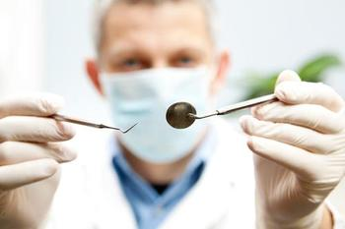

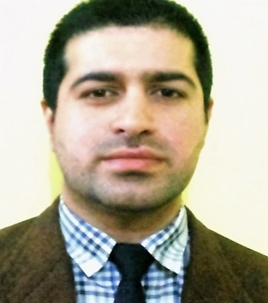
DR TAHIR
TAHIR.336155@2freemail.com
INTRODUCTION
I am a young graduate in dental surgery and a recently qualified EFL teacher with experience of dental practice at government setup. I am an enthusiastic and energetic dentist with a range of treatment and patient management strategies. A voracious reader of non-fictions and a freelance writer on various health/dental science issues. I enjoy outdoor sports and new fitness regimes.
Interntional Tesol Program:
Certificate Of Educational Studies In TESOL JAN –FEB 2016 Grade B+ 120 hour program
EDUCATION
Graduation degree: BDS (dentistry) Year 2009-2014 Obtained at: Jammu University, India. Medium- English
Higher Secondary Part One and Two Year 2006- 2007 Obtained At: Tyndale Biscoe & Mallinson School J&K India Medium -English Grade: Distinction in Part One and Part Two
Matriculation Year: 2005 Obtained at: St Luke’s Convent School J&K India. Medium -English Grade: Distinction
Experience Online Dental consultant
Give online consultations to patients globally as well as in India, answer their queries and provide competent digital consultations at
JUNIOR RESIDENT AT INDIRA GANDHI GOVERNMENT DENTAL COLLEGE AND HOSPITAL,JAMMU august 2016-present
- All minor to major surgical procedures, extractions and assessing in trauma related surgical procedures.
Clinical Dental Practice at ORO-DENTAL SPECIALITY CENTRE,J&K JANUARY 2016-july 2016
- Performed clinical assessments ,evaluation and treatment plan on patients taking into account all parameters of age,sex,dental/medical history.
- Made use of uv-sterlization chambers, autoclave and all modern CDC issued guidelines in clinic and dental practice.
- Devised precision and accuracy in my treatment plans using new innovative techniques, new trends and newest dental materials.
- Collaborated and planned with other dentists to ensure focused and holistic dental practice in public domain.
Core Competencies
.General Oral,Periodontal and orthodontic procedures .Aesthetic And Cosmetic Care .Dental Treatment of Medically Compromised Patients .Emergency Dental Care .Clinical Diagnosis and Treatment Planning. .Interdisciplinary Approach in Dentistry. .Basic Endodontic Procedures
Rotatory internship at I.G. Government Dental Hospital Jammu January 2015 To January 2016
- Worked as an intern in Government Dental Hospital Jammu
- Performed clinical examinations and treatments quickly, efficiently and accurately while being sensitive to the patients comfort during treatment.
- Worked in unison and coordination with other clinical staff choosing effective course of treatments to ensure better patient compliance.
- Carried out school and public health dental educational programs and delivered a holistic approach to dental awareness and health.
Clinical Dental Practice at ORO-DENTAL SPECIALITY CENTRE,J&K July 2014 To Jan 2015
. Diagnosis as well as treats diseases. Injuries and also malformations of teeth, gums and other oral structures.
• Examines patients to define nature of conditions, utilizing x rays, other procedures.
• Cleaning, filling, extractions and replacement of teeth, using rotary instruments, dental appliances, medications and other surgical instruments
Interpersonal Skills and Hobbies
- Developed excellent team work skills while working as a part of tutorial classes at dental school for four years.
- Developed excellent patient care skills through clinical practice that included two years of preclinical and clinical classes and one year of rotatory internship.
- Excellent writing and verbal communication skills by writing exclusively for state newspapers and dental journals on various dental and health related issues.
- Participated in various medical and dental college competitions like poster and painting presentations, debate competitions and secured merit positions.
- I have travelled extensively during my summers at university and enjoy meeting new people and experiencing different cultures.
Personal Details
Date of Birth: 05 September 1991 Marital Status: Single Health: Excellent… (Non-Smoker) Nationality: Indian Registered With State Dental Council.
PUBLICATIONS
- Original research,cancer and precancerous lesions of oral cavity;our experience,jida,vol 10,issue 7-july 2016.
- Original research,Adenamatoid odontogenic tumor,an uncommon cause of facial swelling,ijcmr,volume 3,issue 9,September 2016.
- Original research,clinico-pathological features of central and peripheral giant cell lesions of oral cavity;our experience,ijar2016;2(10);29-33
- Bifid mandibular condyle: a very rate entity case report and review of literature;page 14-18,clinical dentistry,November -2016,issue no 11,vol no X.
- Research article,Auto-Transplantation of mandibular third molar:a case report/journal of science/vol 7/issue 1/2017/XX-XX
- Referees On Request

