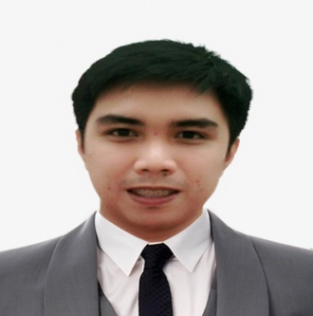
Ephraim
Ephraim.336157@2freemail.com
OBJECTIVE:
To secure a job in the computer industry where I can utilizes my knowledge for the organization’s growth.

QUALIFICATIONS:

- Strong will and desire to succeed.
- Broad minded, skilled and dynamic office and operation/production personnel.
- A Bachelor of Science Degree in Computer Engineering.
- Keen to learn new skills.
- Pro-active, dedicated, flexible and committed to accomplish company targets and goals.
- Positive attitude, customer service oriented with ability to generate client loyalty.
- Honest and hardworking.

EXPERIENCE:
Voiceless Technology, Iloilo City Philippines
CSR – Costumer Service Representative 2016
- Providing customer support in busy call center environments for public utility and insurance industry employers.
- Strategic-relationship/partnership-building skills - listen attentively, solve problems creatively, and use tact and diplomacy to find common ground and achieve good outcomes.
Department of Environment and Natural Resources, Iloilo City, Philippines 2015
AutoCAD Operator
- Verifying map coordinates using AutoCAD Software.

EDUCATIONAL BACKGROUND
College Western Institute of Technology
2016 (Bachelor of Science in Computer Engineering)
Secondary Dumangas National High School
2008
Elementary Dumangas Seventh Day Adventist School
2004

SKILLS

- Knowledgeable in encoding Microsoft Word, Powerpoint and Excel software and other programs.
- Able to integrate the software and hardware devices using arduino microcontroller.
- Able to reformat and install operating system in computer.
- Able to operate AutoCAD software.
- Knowledgeable in programming using HTML, JAVA, C, C+ and Assembly Language.
- Able to network a computer.
TRAININGS/SEMINARS

- Certificate Attendance on DeVcon.
- Certificate of Participation n Cyber Security Fundamentals.
- Computer and Hardware Servicing NCII

Languages Spoken: English, Tagalog
Visa Status: Visit

