CURRICULUM VITAE

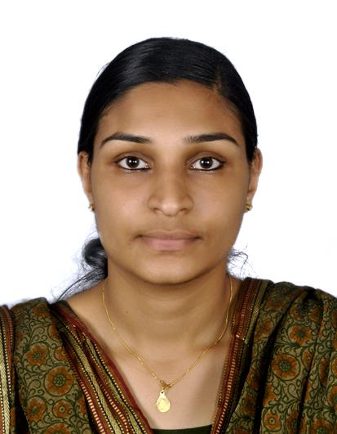
MrS. ANJU
ANJU.336165@2freemail.com
REGISTERED NURSE
BSC NURSING

PERSONAL SUMMARY

A committed medical professional who always keen to safeguard the medical needs ,comfort and emotional wellbeing of patients. I gained 4 years of experience from Sri Aurobindo Institute of Medical Sciences(1200 bedded) Indore, Madhya Pradesh, India and Safal hospital(100 bedded) Chalakudy, Kerala, India where I provided a highest level of patient care and services.

- Ability to work efficiently.
- Know-ICU procedures &equipments
- Tact to deal with different types of patients
- Critical Thinking and Active Listening Skills
- Hardworking ,energetic, flexible, adaptable to change of environment and work schedule

Advocate for patients rights, strive to understand a patient’s needs and concerns

Personal Details

Date of Birth : 1st September 1990
Sex : Female
Age : 26 years
Nationality : Indian
Religion : Christian
Marital status : Married
Languages Known : English, Hindi & Malayalam
Height & Weight : 178 cm & 70 kg.

Passport Details

Date of Issue : 05.05.2014
Date of Expiry : 04.05.2024
Issued From : Cochin

VISA TYPE: Visit visa

CAREER OBJECTIVE
Seeking a challenging position in a busy hospital where my extensive medical professional and practical experience will be fully utilized. And to pursue my career as staff nurse and to utilize my professional skills to serve your esteemed organization and society.

Professional AND Educational qualification

Academic Details
COURSE | UNIVERSITY/BOARD | INSTITUTION | PERIOD OF STUDY
S.S.L.C. | Board of Kerala | SNDP High School, Neeleeswaram | March 2006
Higher Secondary | Kerala Board of Higher Secondary Examination | SNDP Higher secondary school, Neeleeswaram | 2006-2008
B.Sc. Nursing | DAVV University  , Indore | SAIMS College of Nursing, Indore | 2008-2012

liecense details

REGISTERED NURSE license number in India:, DII-issued on 07/01/2013,issued from Madhya Pradesh nursing council, India.

IELTS 6 band score passed on 10/12/2016.

Work Experience

DESIGNATION | ESTABLISHMENT | EXPERIENCE | PERIOD
Staff Nurse | Sri Aurobindo Institute Of Medical Sciences. Indore(M.P) India. | Surgical ICU  Onco surgery ward | 16/10/2012 to 01/04/2015
Staff Nurse | Safal hospital Chalakudy.Kerala,India | Surgical Ward | 01/05/2015 to 30/11/2016

Area of Expertise

- Provide total and direct nursing care to patients needing advanced, skilled or complex care.
- Carry out preliminary patient assessment from head to toe; record baseline vital signs such as body temperature, pulse rate, blood pressure, and respiratory rate.
- Handle admission, discharge and transfer out of patients.
- Versed in performing medical procedures such as peripheral line insertion , CPR management, defibrillation, ECG, cardiac monitoring, tracheotomy care, nasogastric tube insertion & feeding, catheterization, bladder and bowel irrigation, blood transfusion, extubation, oxygen administration,ET suctioning, Echocardiography, major and minor dressing, pleural tapping assist in Tracheostomy, assist in Lumbar Puncture, assist in Bronchoscopy, assist in centralline and arterial line insertion, predict emergencies and act accordingly .
- Recommend changes to policies or procedures and working practices within the area.
- Confer with team members to assess, plan, complete and evaluate patient care plans.

Proven Job Role

- As working in well equipped intensive care unit under the administrative control of the Nursing Superintendent and supervised by the department in charge.
- Maintaining continuity of care by observing adequate handing over and taking over procedures during change of duty shifts.
- Helping doctors in conducting their rounds as well as during medical examinations.
- Providing nursing care and carrying out medical treatment under instruction of medical staffs.
- Attending to new admissions; informing the medical staff and obtaining instruction for proper patient management. Collecting and sending samples for investigations.
- Participating in in-service education
- Maintenance of good nurse patient relationship
- Prevention of infection and promotion of health.

Medical Equipment’s Know-How

- Cardiac monitor | - Pulse Oxymeter | - Ophthalmoscope
- glucometer | - Nebulizer | - Infusion & Syringe Pump
- Defibrillators | - Laryngoscope | - Non Invasive Ventilators
- Mechanical Ventilators  - Suction apparatus  - CVP scale | - ECG Machine  - Stethoscope | - Sphigmomanometer  - mannometer

Declaration

I do hereby that the information given by me is true and correct in best of my knowledge and belief.

)

