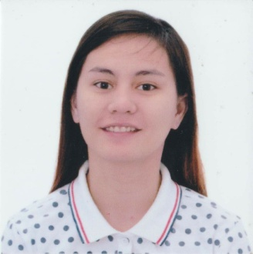
MAYA
MAYA.336168@2freemail.com

EDUCATION
2007-2008 MARIANO MARCOS STATE UNIVERSITY-BATAC, ILOCOS NORTE
Bachelor of Sciences in Pharmacy
2008-2011 PINES CITY COLLEGES-BAGUIO CITY
Bachelor of Science in Pharmacy (Under Graduate)
2015-2016 ST. GABRIEL INTERNATIONAL CENTRE FOR QUALITY LEARNING-LAOAG CITY
Caregiving NC II (Graduate)

EXPERIENCE
April-May 2009 Intern at Mercury Drug Store
- Checking and dispensing of prescription drugs, providing advice on drug selection and usage to physicians and other health care professionals and counseling patients in proper use of medicines.
April-May 2010 Intern at Baguio General Hospital
- Compounding and dispensing for indoor and outdoor patients.
- Proper maintenance and dispensing of regulated/narcotic drugs.
- Filling and labeling of medical containers.
- Checking of the quality of the sources of purchase of all medicine, biological products and other pharmaceutical preparations.
- Maintaining sufficient stocks of antidote for poisoning and emergency medicines.
April-May 2011 Intern at EL Laboratories
- Developing, producing and marketing pharmaceuticals for use as medications.
- Testing the safety and efficacy of pharmaceutical products.
- Checking labels on the pharmaceutical packaging and product information.
- Checking quality assurance on pharmaceutical products.
January 18-29, 2016 Intern at Missionaries of Charity Home of Peace
- Giving Elderly and Child Care, as well as Basic First Aid.
- Checking blood pressure and pulse rate to the patients.
- Bathing the patients, providing them privacy.

SKILLS
- Knowledgeable in Microsoft Office
- Certified Cardiopulmonary resuscitation and First Aid Provider
- Good communication skills

PERSONAL BACKGROUND
Born on January 02, 1991, in Batac, Ilocos Norte, Philippines. Fluent in English and Filipino. Competitive, adaptable, fast learner and can work well with others.

REFERENCES
Available upon request

