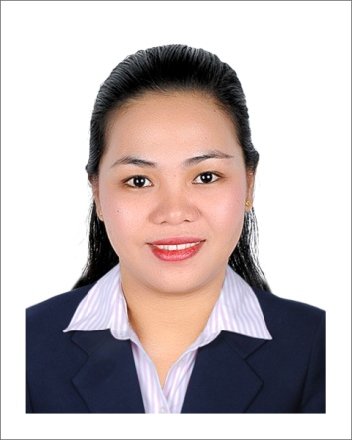
Nova
Nova.336238@2freemail.com

CAREER OBJECTIVES:

- To succeed in an environment of growth and excellence and earn a job which provides me satisfaction and self-development and help me achieve personal as well as organizational goals.

SUMMARY OF QUALIFICATIONS:

- Polite, respectful and act in a courteous manner.
- Work cooperatively in a wide range of personalities.
- Excellent verbal and communication skills.
- Possess excellent communication and inter-personal skills.
- Versatile and multi tasked person. Skilled in handling the public with diplomacy and professionalism

SUMMARY SKILLS:

Computer Skills:
- Microsoft Word, Excel, Access, Outlook and Power point ; Internet & Email
- Good knowledge of office equipments: Computer, printer, scanner & photocopier
- Ability to learn new software applications.
Personal Skills:
- Communication and Interpersonal skills: Good English speaking and writing skills
- Organizational skills: Able to prioritize, emotionally matured, very professional.
- Detailed Oriented: Meticulousness in keeping records and reports.
- Good problem solving skills, multitasking skills, flexible, hard worker and energetic.
- Always maintain a gracious and professional manner when communication with people including client and co-workers.
- Enjoy Working in public.

EMPLOYMENT HISTORY:

Receptionist cum Secretary
(January 2013 up to present)
SKY MUSANDAM TOURISM
-Umm Ramool Road Rashidiya, DUBAI, U.A.E.

- Welcomes visitor by greetings them, in person or on the telephone; answering or referring inquires.
- Directs visitors by maintaining employee and department directories
- maintains safe and clean reception area by complying with procedures, rules and regulations.
- Contributes to team effort by accomplishing related results as needed.
- Arranging appointments and book a hotel and plane ticket for my superior.

EDCATIONAL BACKGROUND:

(June 2008 - April 2012) Bachelor Degree: Bachelor of Science and Information Technology
STI College Tanauan Branch, Philippines
(June 2002- 2004) Undergraduate: Bachelor of Science in Industrial and Organizational Psychology
Polytechnic University of the Philippines, STE
(June 1998 - March 2002) Secondary Graduate: St. Thomas Academy
Sto. Tomas, Batangas, Philippines

PERSONAL INFORMATION

Nationality: Filipino
Birth Date: November 11, 1985
Status: Single
Dialect: English

I hereby attest that the information indicated in this document is true and correct to the best of my knowledge.

