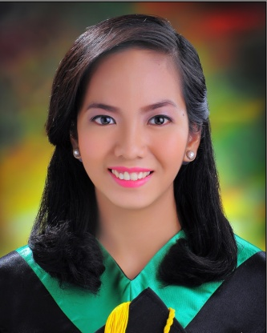
ma. isabel
isabel.336248@2freemail.com

PHARMACIST

As a diligent and zealous pharmacy graduate, I have proven to be a competent and knowledgeable pharmacist with experiences in retail work, customer service, product sales and marketing, and providing general healthcare advice. The internships I had in various areas of pharmacy have led me to be more versatile, easily adaptable, trainable and quick to learn in different work environments with a diverse group of people that qualifies me to contribute to the company’s progress and development.

PROFESSIONAL EXPERIENCE

Retail Pharmacist

Rose Pharmacy, Incorporated  16 E. Osmena cor. L. Bacayo St.,  Guadalupe, Cebu City | June – December 2016

- Dispense over-the-counter drugs, prescription drugs, dangerous/prohibited drugs and loose tablets
- Compound suspensions
- Product Arrangement
- Read and record prescriptions
- Monitor room and refrigerator temperature
- Patient and medication counseling
- Product sales and marketing
- Cashier

INTERNSHIPS
Perpetual Succour Hospital  Gorordo Avenue, Lahug, Cebu City | October – December 2015
Cebu North General Hospital  Kauswagan Road, Talamban, Cebu City | September – November 2014
International Pharmaceutical Incorporated  Go Lam Drive, Pope John Paul II Avenue,  Kasambagan, Cebu City | May – June 2014
Mercury Drug Corporation  Fatima Branch, Basak, Mandaue City, Cebu | May – June 2013
University of San Carlos Pharmacy  P. del Rosario Street, Cebu City 6000 | March 2013
EDUCATIONAL BACKGROUND

2011 - 2015
Bachelor of Science in Pharmacy
University of San Carlos – Technological center
Talamban, Cebu City, Philippines

- Courses include pharmaceutical manufacturing, quantitative pharmaceutical chemistry, biopharmaceutics and pharmacokinetics, drug delivery systems, pharmacy informatics, experimental research and thesis counseling, pharmaceutical calculations, clinical pharmacy, hospital pharmacy, physical pharmacy, pharmaceutical technical writing, pharmaceutical chemistry, pharmaceutical care, biostatistics, biochemistry, pharmacology and clinical therapeutics, pharmacognosy, toxicology, general botany with taxonomy, human anatomy and patho-physiology, microbiology and parasitology, general chemistry and physics

SEMINARS ATTENDED

“Reducing the Global Burden of Disease: Optimizing Pharmacists’ Contribution”
May 25-28, 2016
Waterfront Hotel, Lahug, Cebu City

“Discover the New You”
August 26. 2016
St. Mark Hotel, Cebu City

SKILLS

Meticulous and articulate
Planning, organizing and management skills
Problem solving and analyzing
Communication and interpersonal skills
Research and technical writing skills
Computer literacy skills (MS Word, MS Excel, MS Powerpoint)

PERSONAL DATA

Age | : | 22 years old
Birthday | : | March 8, 1994
Place of Birth | : | Cebu City
Height | : | 5’3”
Weight | : | 50 kgs
Sex | : | Female
Marital Status | : | Single
Citizenship | : | Filipino
Religion | : | Roman Catholic

