RESUME
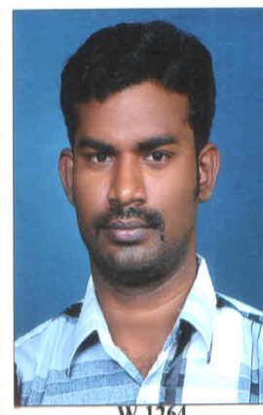
SIRAJUDEE
SIRAJUDEE.336254@2freemail.com

CAREER OBJECTIVE:
To attend a challenging and proven job in my career to fulfill with my acquired knowledge and to reveal my skills to the utmost level.
ACADEMIC PROFILE:
- D.M.E Priyadarshini Polytectnic College Vaniyambadi 60%
- XII Ramakrishna higher secondary school Tirupattur 60%
- X Govt high school Jolarpet 75%
EXPERIENCE:
- CNC Operator(Turnning,Milling) with 3 years Experience Sakthi Auto component LTD, Pallagoundam Palayam , Erode.
Agu-2009 to Agu-2012

- Marketing supervisor(Sales and Service) Gagandhira corporation PLTD,coimbattur.
Nov-2012 to Till Date
PROJECT WORK:
- RECONDITIONING OF SHAPING MACHINES.
COMPUTER KNOWLEDGE:
- M.S office, windows 98.
- Windows 2005 programming C.
- PERSONAL SKILLS:
- Well good communication.
- Adapt to the environmental situations.
- Hard worker.
PERSONAL DETAILS:
Date Of Birth : 14.07.1986
Nationality : Indian
Sex : Male
Marital Status : Married
Language Known : Urudu,Hindi,Telugu, Tamil, English

Declaration:
I hereby declare that the furnished information above is true to the best of my knowledge and belief.

