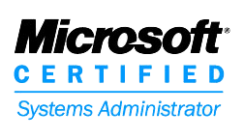
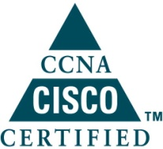
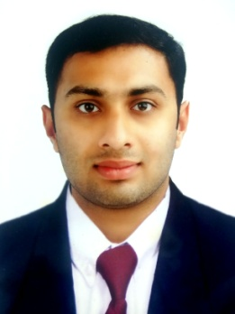

CURRICULUM VITAE

DIXON

DIXON.336264@2freemail.com

Career Objectives

Seeking a position to utilize my skills and abilities in the Computer Science / Information Technology that offers professional growth while being resourceful, innovative and flexible.

QUALIFICATIONS
Description | School/Colleges | Board/University | Course Completion
MCSA | MICROSOFT | Reg No:  cd1055598 | 2014
CCNA | CMS Institute | CISCO | 2014
GNIIT | NIIT | Reg No: R110007600347 | 2012-2015
Bsc IT | Thoppil Institute Of Science and Technology | Sikkim Manipal University | 2010-2013
Higher secondary | St. Joseph's Model Higher Secondary School | Board of Public Examination Kerala | 2009-2010
High School | Don Bosco Higher Secondary School | Board of Public Examination Kerala | 2007-2008
EXPERIENCE
Position | Company | Experience
System Administrator | Francis Diamonds - Kerala , India | Since November 2015

Job Summary

- Effective provisioning - as where ever requirement arises, system provisioning is been provided.
- Installation/configuration - as per the given requirement, installation and configuration is provided.
- Operation and maintenance of systems, which includes hardware and software related infrastructure.
Job History
- Freelance IT Tech in Zorse Lab Pvt LTD - From 2013 to 2014.
- Upgrading PC hardware and software at different locations during various short term consulting assignments.
- Technical Support and troubleshooting PC and laptops.
- Replacing failing or malfunctioning PC components.
- Working with clients to identify computer security needs and educating clients on the proper ways to ensure the security and efficiency of their computer equipment.
- Project documentation preparation of software.

HARDWARE SKILLS
➢ Logic Design | ➢ Computer Networks
- Network Security | ➢ Server Side Programming

SOFTWARE SKILLS
- Operating Systems: Windows-98/xp/vista/win- 7/win- 8/Linux | - Modeling Language: UML | - Web Designing: HTML, XML
- Languages: c, c#, java, .net, asp.net,DBMS | - Office tools: MS-OFFICE | - Database: SQL Server 2005

Professional Certification
- GNIIT CERTIFICATION
- Object oriented programming c#
- Relational data base management system
- Querying and managing data using SQL server 2005
- GUI application using .net frame work
- Software quality assurance and testing
- Oracle 9i program with PL SQL
- Designing, debugging & tuning windows and web application using visual studio 2005
- Data structure and algorithm
- Client server database
- Network administration
- Server administration
- System support

- MCSA CERTIFICATION
- Windows 8 configuring
- Administering windows server 2012
- Configuring advanced windows server 2012 services
- Installing and configuring windows server 2012

- CCNA CERTIFICATION

- Routing and switching
- Trouble shooting
- WAN technologies
- Wireless connections
- ORACLE CERTIFICATION

- Oracle database 10g: introduction to SQL
- Oracle database 10g: PL/SQL fundamentals
Academic Projects

- Designed a BSNL BROADBAND system.
- Using c# (sharp), visual studio 2005(.net frame work) & sql server 2005.
- Duration to complete the project 3 months.
- Designed an E-MOBILE STORAGE system.
- Using c# (sharp) visual studio 2005 (.net framework) & sql server 2005.
- Duration to complete the project 2 months.
- Designed E-Banking system.
- Using ASP .Net with C#, Visual Studio.Net 2005, (.Net Framework) & sql server 2005.
Achievements

- Selected Among 100 Candidates To Get Trained In Windows 8.
- What All Technology Behind It, Front End & Back End Coding.
- Introduction to windows app development
- Windows 8 first step
- Presented Paper On “Xml” At NIIT

Extra Curricular Activities
- Winner in philately at School level.
- Member of social service club.
- Winner in relay at school level.
Hobbies
- Listening music
- Playing football

Personal Qualities
- Positive Attitude & Self Confidence.
- Hard working & Self-motivated.
- Practical thinking.

Personal Details

Date of Birth : 10-12-1991
Sex : Male
Marital Status : Single
Religion : Roman Catholic
Nationality : Indian
Language Proficiency : English, Malayalam, Hindi

Declaration
I hereby declare that the above written particulars are true to the best of my knowledge and belief.

