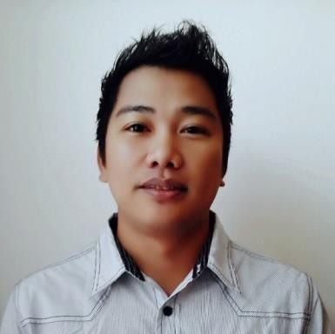
Giovanni
Giovanni.336320@2freemail.com

Professional Objectives

Obtain a position that will enable me to use my strong sales skills background, IT skills and abilities to work well with people

Key Skills and Expertise

* Over 8 years of experience working as Sales Representative and IT Technician
* Excellent problem solving skills, able to work productively and instinctively with initiative
* Able to build good relationship with colleague and customers
* Reliable, trustworthy and excellent understanding of customers care and service
* Expert on solving IT problems
* Strong Background in Trouble shooting Software and hardware instalation

Experience

Position: Company:

Position:
Company:

Position:
Company:

Key Account Manager March 2016 – September 2016
50 th REVE NUE (J LT 1Lake Plaza)
* Maintaining a long term relationship with accounts and maximizing sales opportunities within them.
* Provide Emailing Traffic using CPC and CPM model.
* Research and contact potential client.
* Ensuring service unit in good condition.
* Maintains Printer and other equipment.
* Responsible in creating hasoffers/CAKE and editing HTML for preview.
* Managing Company platform.
* Monitoring co-employee and creating Computer overview sheet.
* Uploading and running campaign for Client.

IT Support Technician January 2011 – December 2015 SEI N DIG ITEL C OMPUTER (BRANCH)
* Responsible for supporting: Windows XP/Vista/Windows 7, 8 and 10,
Office 2003, 2007, 2010 and 2013, Backup products and Anti-Virus products.
* Responsible for the installation and maintenance of IT equipment including
Printers, Scanners, X-terms and workstations.
* In charge of technical section and sales technician
* Diagnose and repair all kinds of IT related issues.
* Deploy and manage computer network structures.
* Handle customer support
* Managing technical division’s work force
* Ensuring the company’s asset

Branch Head Technician March 2007 –November 2010
PC PLUS COM. CENTER (BRANCH)
* Provide computer support for those who have computer problem.
* In charge of technical section and sales technician.
* Diagnose and repair all kinds of IT related issues.
* Deploy and manage computer network structures.
* Handle customer support
* Ensuring the company’s assets.

Position: STORE SUPERVISOR June 2006-February 2007
Company: J-J COMPUTER CAFE
* Responsible for the repair and maintenance of printers, monitors, scanners and hardware.
* Responsible for loading new software and systems on existing equipment.
* Performed upgrades on existing computer systems.
* Installation and updates on games and anti-­‐virus programs
* Maintains cleanliness and orderliness of the shops area.
* Responsible in assisting customer courteously.

EDUCATIONAL BACKGROUND
UNIVERSITY OF NORTHERN PHILIPPINES – VIGAN ILOCOS SUR
BACHELOR OF ELEMENTARY EDUCATION
*Major in GENERAL SCIENCE (2001-2005)

TECHNICAL EDUCATION & SKILLS DEVELOPMENT AUTHORITY (TESDA)
COMPUTER HARDWARE SERVICING II

ELIGIBILITY
` Licensure Examination for Teachers (LET)
Professional regulation commission (PRC) Baguio
City Registration no:
Registered December

National certificate II
(NC II) Computer hardware servicing
Awarded by: TESDA (Technical Educ. &Skills development authority)
Certificate number:
Issued: march 1 2015

Personal Information

Age : 32
Birthday : June 21, 1984
Marital Status : Married
Visa Type : Visit Visa
Nationality : Filipino

