CURRICULUM VITAE

SHIYAS
SHIYAS.336324@2freemail.com
REGISTERD NURSE
b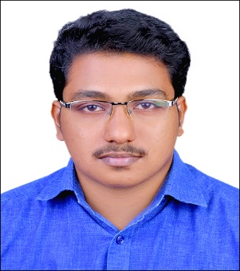
OBJECTIVE

- To secure a deserving position in the field of nursing in your esteemed organization to sharpen my existing skills and be a healing and to the needed ones.
QUALIFICATION SUMMARY
- Over 3 years of experience as a Staff Nurse in Emergency Department and 1 year experience in medical insurance.
- BLS
- ACLS
- Advance Airway Management.
MOH LISCENSE DETAILS
LISCENCE EXPIRY:
CATEGORY : REGISTERED NURSE
PERSONAL DETAILS
Date of Birth : 21-05-1988
Nationality : Indian
Sex : Male
Marital status : Single

PASSPORT DETAILS

Date of Expiry - 20/08/2022

PROFESSIONAL QUALIFICATIONS

COURSE | INSTITUTION | UNIVERSITY | YEAR OF PASSING
B.Sc NURSING  [4Year] | S.S.INSITUTE OF NURSING SCIENCES,DAVANGERE | RAJIVE GANDHI UNIVERSITY OF HEALTH SCIENCES, KARNATAKA. | 2012

PROFESSIONAL EXPERIENCE
Working as Medical Insurance Officer at Ibin Sina Medical Center, Ajman since Dec 16th 2015.
Working Experience of 31 months in Casualty at Govt.Taluk Head Quarters Hospital Punalur, Kerala,India, from August 20th 2012 to March 30th 2015.
Working Experience of 7 months in Casualty at St.Thomas Hospital ,Punalur,Kerala,India from 01/05/2015 to 04/12/2015

