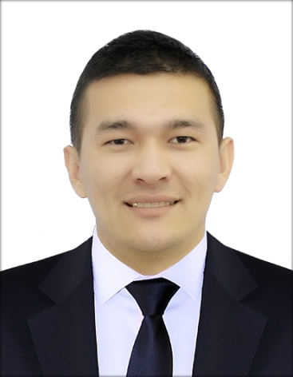
NURIDDIN
NURIDDIN.336428@2freemail.com
Nationality: Uzbekistan
Visa Status: Tourist Visa (Exp. Date: 05/02/2017)
Date of Birth: 17/02/1993
Marital Status: Single

PERSONAL SUMMARY

- Having an enthusiastic and positive attitude and working hard to ensure that customers/guests receive an excellent level of service whilst at the same time ensuring the highest level of service for the hotels/restaurants. Presently looking for a waiter/bellboy services position with reputable hotels/restaurants.

Work Experience

“Grand Mir” Hotel Tashkent, Uzbekistan
Waiter 2014 Jan - present
Duties:
- Greeted new customers and escorted them to their tables.
- Presented menus and answered questions about the cuisine, making recommendations upon request.
- Wrote customers’ orders and conveyed to kitchen staff.
- Took orders from customers and served food, drinks and deserts.
- Served specialty dishes to customers at tables as required.
- Checked to ensure that customers are enjoying their meals – took action to correct any issues.
- Prepared bill/receipts and collected payment from customers.
- Cleaned tables and other areas as needed, after clients departed.

“Ramada Tashkent” Hotel Tashkent, Uzbekistan
Bellboy 2012 Feb -2014 Jan
Duties:
• Greet guests as they arrive and guide them appropriately
• Assist guests with luggage when checking in/out
• Hail taxicabs and assist with inquiries
• Inform guests of the hotel’s procedures and policies and provide emergency information
• Assist in cleaning up lobby and lounge
• Help valets during busy hours
• Deliver messages and run errands
• Assist with newspaper deliveries to the rooms
“Gulistan” Hotel Sirdaryo, Uzbekistan
Doorman 2011 June - 2012 Jan
Duties:
- Welcoming guests / customers at the entrance and opening the door politely
- Assisting them with their desired service and guiding them to the appropriate counters, conveying information regarding directions
- Receiving high profile customers at the cars and taking them to the hotel
- Greeting the customers with appropriate verbiage maintaining a high-level of graciousness
- Guiding the customers to the proper parking and assisting them in parking their vehicles
- Following standard farewell procedures for leaving customers and calling the taxi/cab as per their needs

Skills

Languages English – fluent
Russian – fluent
Uzbek - native

Computing Excel, Photoshop, Microsoft Office Word, Installed and Setup Computer programs

Education

2009-2012 Uzbek State Academic Lyceum
Faculty: English, mathematic

2000-2009 High school- N8, Sirdaryo

Achievements
• Awarded the Best Employee of the Year title related provision of excellent guest services in 2014/15
- Good working skills in POS System, Fidelio and Opera Hotel information System, MS, Microsoft Office (Word, Excel, Power Point), Internet explorer.

Key Skills and Competencies
- Seven years’ experience as waiter/bellboy in the restaurants/hotels.
- Customer service skills – Top notch communication skills and professional work ethic.
- Multi-tasking capability.
- Ability to work-in and lead a team – Good leadership/delegating abilities for supervising waiters’ staff (for those who apply for head of waiters).
- Sales and marketing skills.
- High school diploma/college.

Excellent communication and interpersonal skills.

REFERENCE
Available upon requests.

