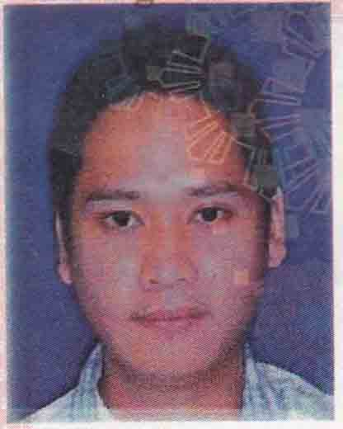,

**CURRICULUM VITAE**

**CURRICULUM VITAE**

**Richard**

[**Richard.336464@2freemail.com**](mailto:Richard.336464@2freemail.com)

**OBJECTIVES:**

To serve the best with profile that would utilize my strength, experience and qualities of self-motivation and interest to explore the new horizons and my ability to be an efficient member of a team to get opportunities.

**WORK EXPERIENCE:**

Icon Computer Shop February 04, 2005-March 17, 2007

Philippines

Salesman

Universal Robina Corporation July 3, 2007-April 17, 2009

Bataan,Philippines

Warehouseman

First Hi-Tech Enterprises March 22, 2010-March 17, 2013

Taoyuan,Taiwan

Production Operator

Purple Mice Events Company July 21, 2013- August 30,2014

Dubai UAE

AV Technician

Avion Integrated Solutions Oct. 27, 2014 – Dec. 7, 2015

Dubai UAE

AV Technician

Fractal System Dec. 10, 2015- Aug. 22, 2016

Dubai UAE

AV Technician

**SUMMARY OF QUALIFICATIONS:**

* Outstanding experience and skills for warehousing.
* Computer knowledge.
* Excellent communication Skills.
* Flexible and exceptional ability to work with other people as a team.
* Established leadership skills.
* Exceptional organizational skills.
* Detailed knowledge of techniques, principles, and objectives of sales.

**Warehousing Experience**

* Responsible for the receipt, storage, display, disposal, and distribution of all types of property in the warehouse.
* Duties include the unloading of a wide variety of property, proper storing of the property, and the advantageous display of items for proper distribution.
* Loads and unloads property at warehouse with due precaution for the safety of personnel and the proper care of the materials and equipment.
* Helps store and display items.
* Operates and cares for all rolling stock used in loading, unloading, and the transfer of property.
* Helps in the proper distribution of all supplies and property items.
* Performs other duties as assigned by the Director of Purchasing**.**

**CURRICULUM VITAE**

**Production Operator Experience**

* Setup the production equipment and supplies before executing the job.
* Operate equipment safely and effectively for production processing.
* Ensure that equipment are maintained in good and safe working condition.
* Inspect equipment to identify any replacements, malfunctions and repairs.
* Perform regular equipment maintenance to ensure production capacity and quality.**.**
* Provide assistance to junior operators in their assigned responsibilities.
* Repair and clean the equipment when needed.
* Work under the guidance of Supervisor to perform and complete the assigned duties in timely manner.
* Evaluate equipment performance and recommend improvements..
* Follow safety procedures and company policies for equipment operation.
* Recommend process improvements to enhance operational efficiency and safety.
* Identify and report unsafe operations to supervisor immediately.
* Maintain the work are clean, safe and organized.

**Sales and Customer Service Experience**

* Responsible on how to communicate and give good service to the costumer.
* Making the costumer at ease during their shopping.
* Preparing vouchers for costumer credit card and gift check transaction.
* Assist customer on selecting the product, answering their questions about the product.
* Resolve costumer complain.

**Educational attainment:**

* **College**  : **Bachelorof Science in IND’L.Tech (Mechanical Tech.)**

Bataan Peninsula State University 2001

: **Bachelor Of Science In Computer Engineering**

Bataan Heroes Memorial College 2003 (2nd year)

: **Diploma in Computer& Electronics Technology**

STI College 2005

**PERSONAL DATA**

Date Of Birth : 24th March,1982

Nationality : Filipino

Civil Status : Single

Sex : Male

Languages Known : English,Tagalog, and Mandarin Chinese

I hereby declare that the above mentioned statements are true and correct to the best of my knowledge.