(Registered Nurse with DHA Eligibility letter)

1.Personal Details
- Name ………………. Helen
- Email :-Helen.336472@2freemail.com
- 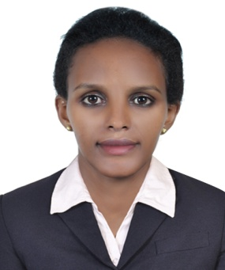
- Date of Birth …………... 16-Apr-1987
- Sex…………………….. Female
- Address ……………….. Dubai, UAE
- Nationality……………... Eritrean

2. Educational Background

Academic  Rank | Year of study | Educational Institution | Remark
Bachelor | Sept, 2009 -June,2013 | Asmara college of Health Science (ACHS) | BSC in NURSING
Diploma | Mar, 2003 - Sept, 2004 | College of Nursing and Health Technology Asmara | Diploma in Associate Nurse
High school | Sept,1998-June,2001 | Denden Secondary school | High School Diploma

3. Training Certifications

- On severe complicated and uncomplicated Malaria 25/Feb/2008-05/Mar/2008
- On operating Room Technician program from 16/Sept/2004-16/Dec/2004
- On Basic Life Support 21-Jan-2016

4. Work Experience
I. Starting 7/2013 to 05/2016, was working in Bete mekae community Hospital as a
Registered Nurse.
- Duties and Responsibilities
✓ Managing emergence cases.
✓ Monitoring, assessing, evaluating and managing patent’s condition.
✓ providing health education for individuals and families.
✓ Carryout a comprehensive nursing process.
✓ Administration of medication and treatment.
✓ Antenatal and child health care
✓ consulting with physicians and other health care professional

II. Starting from 17/1/2005 to 31/7/2009 , was working as Associate Nurse as OR(Operating
Room) Technician in Halibet referral Hospital, Asmara

     ➢ Duties and Responsibilities

✓ Assisting major and minor operations.
✓ Pre- operative, intra-operative and post -operative patient care
Establish treatment plan, operating medical equipments.

5. Language Skills

I have the ability to speak, read, and write the following languages.
Language | Written | Reading | Spoken
Tigrigna | Fluent | Fluent | Fluent
English | Fluent | Fluent | Fluent
Arabic | Fair | Fair | Fair
Amharic | Good | Good | Good

6. Publication/Research Activity

✓ Senior paper on partial fulfillment of bachelor degree on Nursing, Asmara College of
Health Science titled “Exposure of Nurses to occupational Hazards in Halibet National
Referral Hospital.

7. Award
- Great Distinction in Asmara College of Heath science,
Graduation Day, 2013 ,B.Sc in Nursing
- First prize winner in college of Nursing and Health Technology graduation date
Sept, 2004
8. Computer skills

Well versed skills in Microsoft office application (Ms Word, Ms Excel, Power point, software
(Documentation and registration) and internet

9. Hobbies
- Reading scientific journals ,newspapers, and books
- Listening music

