**Oussama**

22 years old

Email : [**Oussama.336480@2freemail.com**](mailto:Oussama.336480@2freemail.com)

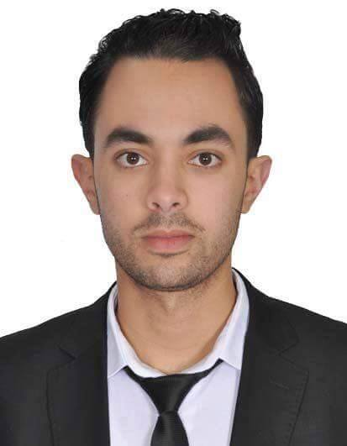

**Studies**

[2015-2016] : Hotel management Diploma at l ISTH , meknes morocco

[2011-2012] : Bachelor of letters, MEKNES

Languages :English : Fluent

Arabic : Native

French : Fluent

Computer knowledge :Word, Excel,PowerPoint .

* **01/01/2011 to 02/04/2014 At Le MIRAGE Restaurant**

***Meknes,Morocco Position :* waiter**

* **02/05/2014 to 31/11/2014 At Zaki hotel**

***Meknes,Morocco Position:* waiter**

* **31/11/2014 to 01/09/2015 At Swani Hotel**

***Meknes,Morocco Position:* waiter**

* **15/09/2015 to 01/06/2016 At Dalia hotel.**

***Meknes,Morocco Position:* waiter**

**Professional experiences**



* **I am able to perform well in high-pressure environments as I am very competitive with a strong motivation to succeed. An example of that is the way i was able to balance work and study with my sporting interests while at University.**
* **Additionally , I have always had a part-time job alongside my studies, or in the summer holidays. This demonstrates personal motivation to continually develop myself and my skills.**
* **A good sense of humor**
* **Punctuality**
* **Special talent for learning menu items and describing them appropriately to patrons**
* **Excellent skills in maintaining cleanliness and personal hygiene standards**