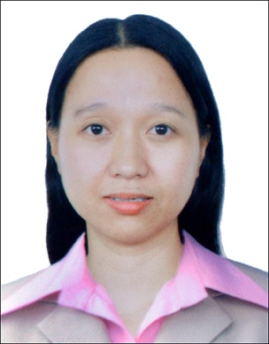
GLAIZA
GLAIZA.336490@2freemail.com
Job Objective: To do whatever task assigned to me to the best of my knowledge and to give/share my talent in any improvement of the company.
Characteristics: Hardworking, flexible, can work under pressure, honest, punctual and with self- determination.
EXPERIENCE
SERVICE CREW - May 2004 - November 2004
Greenwich Pizza Corporation – South Mall Las Piñas City
DUTIES AND RESPONSIBILITIES
Dependable Service Crew experienced in taking food orders and safely handling food while checking for proper temperatures and any food flavor. Focused on producing quality food and providing excellent customer service.
- Comfortable standing for long time periods
- Active team worker
- Learns Quickly
- Focused and reliable
- Physical fit
- Clean and organized
- Prepared all ingredients
- Flavored Pizza and Cook food orders
- Back up other members to keep team workflow
- Entertain customer and assist the order of customer
- Maintain the cleanliness of Flavored area
- Perform closing duties clean and wash all materials

EXPERIENCE
PRODUCTION OPERATOR – July 2006 – November 2006
Excel Quality, INC. – Commonwealth Avenue Quezon City
PRODUCTION OPERATOR – January 2007 – May 2014
Hoya Glass Disk Phil. INC. – FPIP Tanauan City, Batangas C
DUTIES AND RESPONSIBILITIES
Flexible and resourceful Production Operator and Machine Operator who has maintained perfect attendance and safety records throughout a nine years career. Experienced in Visual Inspection for detection all Not Good or not qualified for product then separated the good and Not good. Careful to handle all product for maintained the quality. Focused on producing quality product and providing excellent customer service.
- Before Start of the shift and End of the shift clean all area
- Get the product approved by QA
- Using projector lamp inspect all glass disk then separate the not good glass disk
- Encode all the good product then made a barcode
- Make sure all the product in a good condition
- Follow regulations, safety guidelines, and company procedure at all times
EXPERIENCE
MACHINE OPERATOR – July 2014 – December 2014
NXP Semiconductor – LISP Science Park1 Cabuyao, Laguna
DUTIES AND RESPONSIBILITIES
- Before start work clean the machine
- Prepared the crystal product then set up the machine
- Set up the machine including shapes and size for cutting
- Using microscope measured the chipped of crystal
- Continuously inspected and maintained work area free of debris
- Followed all standard operation procedures and safety guidelines

EDUCATION
Associated Computer Science – Literate of Computer
Limay Polythecnic College – Limay, Bataan
Skills – computer literate, Microsoft word, excel, power point

Personal Information

Birthday: August 12 1985
Birthplace: Lamao, Bataan
Civil Status: Married
Citizenship: F ilipino
Height: 5’3”
Weight: 49 KGS.
Religion: Roman Catholic
Sex: Female

