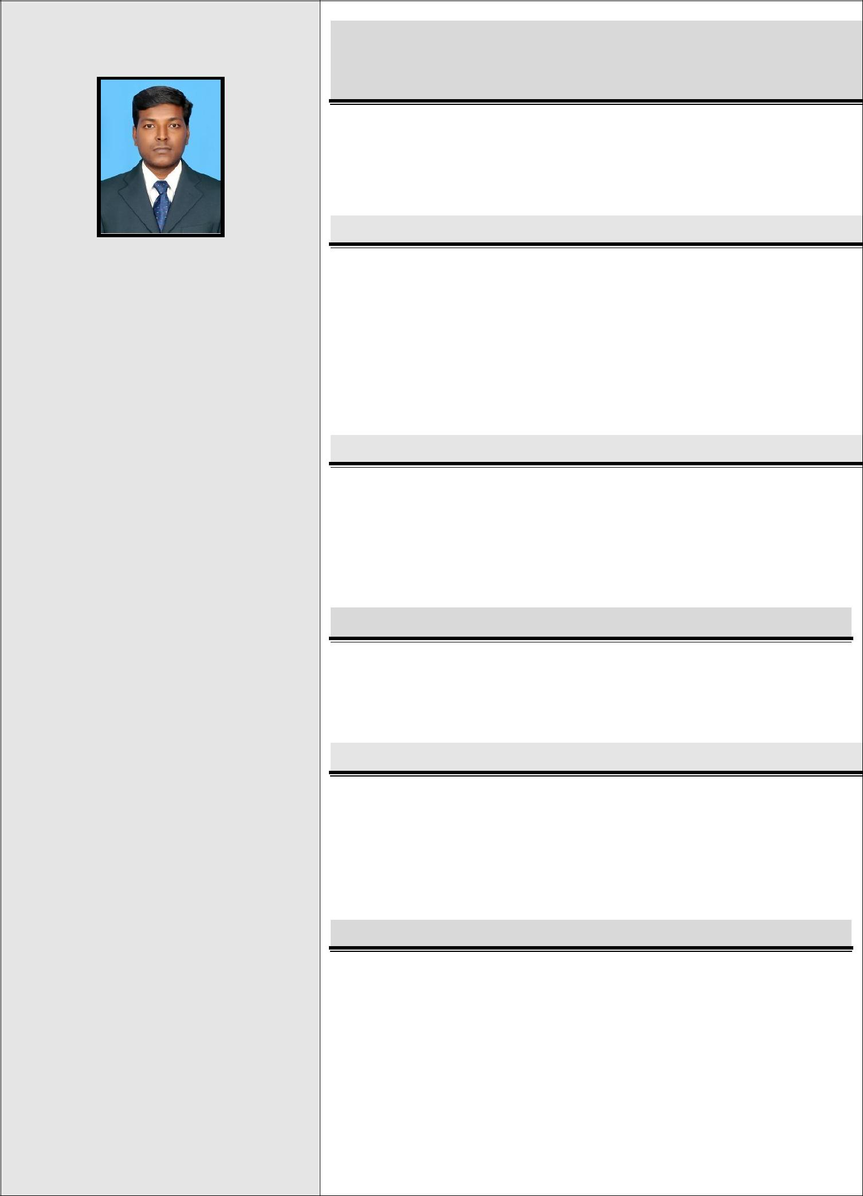
JAGADEESAN

E-MAIL: jagadeesan.336540@2freemail.com

PERSONAL PROFILE:

Date of Birth :07/06/1985

Gender :MALE

Marital status :UNMARRIED

Nationality :INDIAN

LANGUAGES KNOWN :

Speak : Tamil, English.

Write : Tamil, English.

Read : Tamil, English.

HOBBIES & INTERESTS:

Programming, Movies

Music, Cricket
CURRICULUM VITAE

CAREER OBJECTIVE

Seeking a good position to utilize my skills and abilities in our organization that offers professional growth while being resourceful, innovative and flexible.

ACADEMIC PROFILE

- MCA in Vels University with 93.55% (2010-2013)

- BSC(CS) in Madurai Kamaraj University with 64.41%(2003-2006)

- +2 State Board with 67.66%(2002)

- 10 ^{th} State Board with 68.40%(2000)

TECHNICAL PROFICIENCY

▪ | Languages | C, C++,JAVA.
▪ | Database | SQL.
▪ | Operating Systems | Windows 2007.

CERTIFICATION

 Software Package

COURSE | : | JAVA
INSTITUTE | : | NIIT

ASSETS

- Calm and determined under pressure

- Effective problem Solver

- Team management skill

- Success motivate

FINAL YEAR PROJECT

Mini Project:

Title:“Online Library Management System”.

Front End: JSP Back End: MySQL

Description: Online Library Management System for monitoring and controlling the transactions in a library. Function is in like adding new member, new books, and updating new

WORK EXPERIENCE:

After completing UG from 8th

June 2006 to 23rd April 2010 worked as DATA ENTRY OPERATER (Maintenance Department) and 14th

Nov 2013 to 4th July 2014 as ENTRY LEVEL JAVA PROGRAMMER in

NIFTY SOLUTION PVT LTD in

Chennai.

PASSPORT DETAILS:

Passport Type: P

Date of Issue:05-11-2008

Expiry Date: 04-11-2018

Visa Expiry: March 20 - 2017
information, searching books and facility to borrow and return books.
Main Project:

Title:“Robust Face-Name Graph Matching

for Movie Character Identification”

Front End: J2EE Back End:SQL

Description: Automatic face identification of characters in movies has drawn significant research interests and led to many interesting applications. It is a challenging problem due to the huge variation in the appearance of each character.

NIIT Project: ”Smart Accessories “

Front End: JSP Struts Back End: SQL Server 2008

Description: In this project a website is designed for buying products online. Users can register with username and password. They can buy things online and add it to their shopping cart.

ACHIEVEMENTS

- Two times getting first prize in “Tennikoit”game from

inter level competition in my UG .

- I presented 3 papers in National Level Seminar in my PG.

- I attended “Android” Workshop in Griffin Education

DECLARATION

I hereby declare that the above-mentioned information is correct up to my knowledge and I bear the responsibility for the correctness of the above-mentioned particulars.

