Rajat

Rajat.336545@2freemail.com 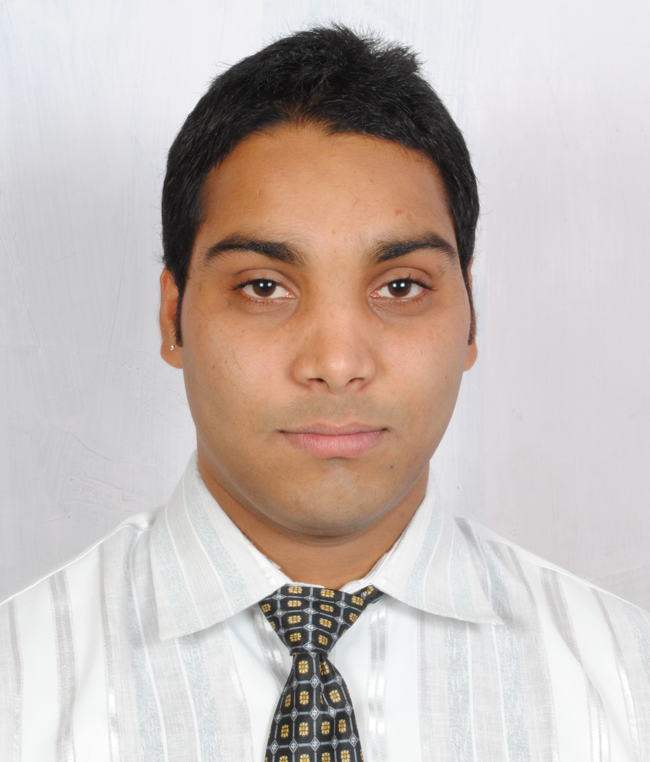

PROFILE & CAREER OBJECTIVE:

To be associated with a progressive organization which can provide me with a dynamic work sphere to extract my inherent skills as a Professional, use and develop my aptitude to further the organization's objectives and also attain my career targets in the progress.
Willing to relocate to: Dubai

Professional Experience

HR recruiter

Paramount Management HR Solution-(June 2016 - November 2016)

- Design and implement overall recruiting strategy.
- Develop and update job descriptions and job specifications.
- Perform job and task analysis to document job requirements and objectives.
- Prepare and post jobs to appropriate job board/newspapers/colleges etc.
- Source and attract candidates by using databases, social media etc.
- Screen candidates resumes and job applications.
- Conduct interviews using various reliable personnel selection tools/methods to filter candidates within schedule.
- Assess applicants' relevant knowledge, skills, soft skills, experience and aptitudes.
- Onboard new employees in order to become fully integrated.
- Monitor and apply hr recruiting best practices.
- Provide analytical and well documented reports to the rest of the team.
- Act as a point of contact and build influential candidate relationships during the selection process.
- Promote company's reputation as "Best place to work".

Technical Recruiter

Rangam Staffing pvt ltd - (November 2015 - May 2016)

- Handling the full cycle of recruitment - source, screen, validate, offer, and close resources for job requirements.
- Responsible for all types IT and Non IT requirements and maintaining all the client's updates.
- .Good experience working on the recruitment process for contract, W2, Corp-Corp etc.
- Ability to handle volume recruiting in a fast paced, (un) structured environment, adhering to strict deadlines with strong sense of urgency, flexibility, and adaptability.
- Understand the junior members as individuals - personality, skills, strengths, needs, aims and fears.
- Assist and support individuals - plans, problems, challenges, highs and lows.
- Identify and agree appropriate individual responsibilities and objectives.
- Give recognition and praise to individuals - acknowledge effort and good work.
- Identify, develop and utilize each individual's capabilities and strengths.

Education & Certifications

MSc. in Electronics (July 2012 - August 2014)
Barkatullah University - Bhopal, Madhya Pradesh

B.Sc. in Electronics (July 2009 - April 2012)
Barkatullah University - Bhopal, Madhya Pradesh

Higher secondary School (July 2008 - Arpil 2009)
Bhopal Academy Higher Secondary School Bhopal - Bhopal, Madhya Pradesh

High School ( July 2006 - Arpil 2007)
Bhopal Academy Higher Secondary School Bhopal - Bhopal, Madhya Pradesh

Off Note
COMPUTER SKILLS

- MS Office (PowerPoint & Excel)
- Microsoft Works, Outlook

AWARDS AND ACCOMPLISHMENTS/ EXTRA CURRICULAR ACTIVITIES
- Won Basket Ball Tournament on State Level.
- Participated in Basket Ball Tournament on National Level.
- Participated in Kick Boxing Tournament on National Level in Orissa.

Personal Details
Date of Birth : 13th March 1993
Gender : Male
Languages Known : Hindi and English

