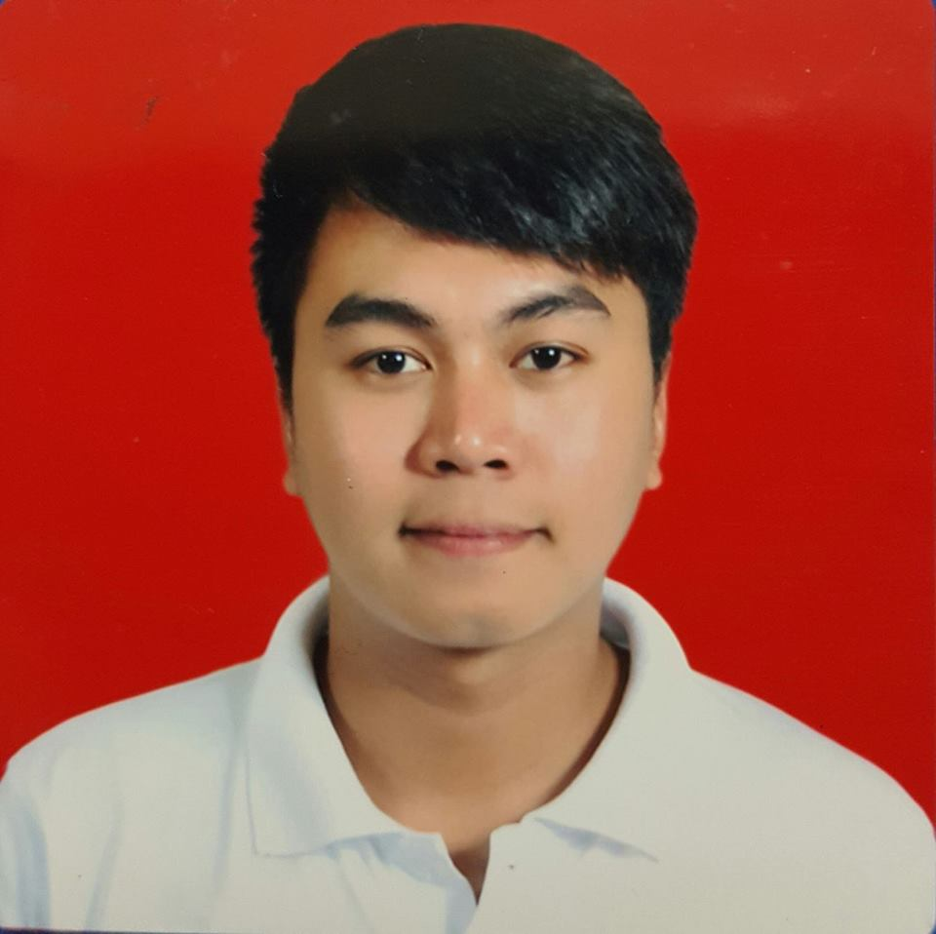
VAN
Van.336552@2freemail.com

CAREER OBJECTIVE

- To use and enhance my professional skills and knowledge where my abilities can be exposed to a challenging opportunities.

TECHNICAL EXPERTISE

Operating System : Windows XP, 7 and 8

Software : Android, Auto Cad, Cisco Pocket Tracer, Eagle

Background In : Networking, C++/Turbo C, Operating System

IT/Skills : PC/Laptop Trouble Shooting, Configuration, Microsoft Office Application

PROFESSIONAL EXPERIENCE

GAISANO GRAND MALL KORONADAL April 2015 – December 2016
Koronadal City, Philippines

Designation: Management Engineering In-charge

Duties and Responsibilities
- Assist management in direct oversight of department’s daily operation.
- Supervise installation and initial start-up of engineering equipment.
- Troubleshooting and networking of computer system.
- Decide on equipment’s, materials and subcontract sources.
- Assist in preventing high cost of electricity.
- Perform and record machine tool capability studies.
- Participate in assigned long-term preventive maintenance programs and projects.
- Supervise engineering works (Electrical, Mechanical, Plumbing, Construction)
- Performs other tasks as assigned.

ON JOB TRAINING

MARBEL SERVICE TELEVISION SYSTEM, INC. March 2013 - June 2013
Koronadal City, Philippines

Responsibilities
- Troubleshooting network problem.
- Beaming of satellite.
- Selecting, planning, and scheduling various programs at the television station.
- Monitor System Line.

AFFLIATIONS

Junior Computer Engineering Society March 2013 – March 2014
Notre Dame of Marbel University
Executive President

- Preparing year plans.
- Activity events and planning, school policy support from students, budget allocation, fiscal planning, recognition of developing issues pertaining to students, and communication between faculty/staff and the student body.
- Preparing communication letters
- Organizing even.

Junior Computer Engineering Society March 2014 – March 2015
Notre Dame of Marbel University
Executive Vice President

- Preparing communication letters.
- Organizing events.

TRAININGS AND SEMINARS

- Trained and Certified National Competency II passer in Computer Hardware Servicing.
- Robotics
- Microcontroller Workshop
- Leadership Seminar
- DevCon (Web Frameworks, JavaScript Game Frameworks, and Mobile Application Development)

ACADEMIC QUALIFICATION

Bachelor of Science in Computer Engineering
Notre Dame of Marbel University
Koronadal City, Philippines
June 2009 – March 2015

PROFESSIONAL SKILLS

- Excellent oral and written communication.
- Computer literate.
- Supervisory skill.
- Set, meet deadlines and goal.
- Knowledge in preventive maintenance continues improvement and safety.
- Engineering work experience in a high tech merchandising environment.

PERSONAL INFORMATION

Date of Birth : July 24, 1992 Nationality : Filipino
Status : Single

