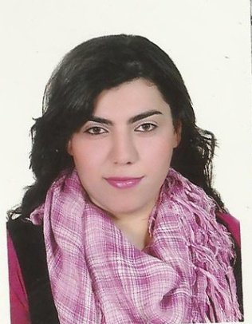
Samira
Samira.336561@2freemail.com

PERSONAL DETAILS
- Date of birth : 04-01-1990
- Place of birth : Egypt.
- Nationality : Egyptian.
- Marital status : single.
- Addresses : Dubai – Jumeriah

LANGUAGES KNOWN
- Native language Arabic.
- Very good command of both written and spoken English.

CAREER OBJECTIVE
Seeking challenging position to utilize, increase communication skills and achieve higher ambitions to join in professionally organized firm, where I shall strive to bring the continuous records of accomplishment that will intensify both the image and performance of the organization, where I can I also increase or develop my knowledge and career experience to an extend level to insure customer's satisfactions, meeting organization's policies and providing the opportunity for career growth and future improvements.

SKILS
- Strong negotiation and interpersonal skills.
- Very good communication skills.
- Dedicated and hard working attitudes.
- Determined, enthusiastic and commitment.
- Ability to work under pressure environment.
- 4 years customer service experience.
- Excellent computer skills (very good knowledge of Microsoft office).

PROFESSIONAL PROFILE EXPERIENCE

Sales manager in El Ard General trade company UAE (Mamamia shop) (December 2015 - till now).
. Handling inquiry for customer asking about clothes
. Handling cashier transactions.
. Handling inventory purchases and sales.
Customer Service Representative, (Vodafone Egypt account 888 – technical support 2828 & sales in store Vodafone) (march 2012 – November 2015).
- Handling in bound calls to the all customer having a problem from ADSL land line – Mobile internet – 3G Router – MiFi – USB
And handling in bound calls to the any customer having a problem in balance mobile – credit transfer problem – info from any rate plane – info from rate plane mobile internet.
- Handling complain customer having a problem and follow up with any department to try to solve problem of customer and follow up with customer to check problem is already solved.
- Making call out bound if case not closing and need to follow up with customer till close the case and problem solved

Sales agent in stores Vodafone
- handling customer face to face and answer all inquiry and sell mobiles, lines, 3G routers _ USB _ MIFI

Customer Service Representative, (NTRA – Telecom Egypt) (February 2011 – January 2012).
- Handling out bound calls and confirm with customer data from line
- Handling out bound calls and asking customer some question to check Customer satisfaction with the joint communications company out of saluting systems and Internet services and network services and customer service employees of the company and assigned to exciting permanent them and held by the company

Customer Service Representative, (Xceed – Telecom Egypt) (June 2010 – January 2011).
- Handling in bound calls to maintain the provided services to telecom Egypt account 111
- Handling and report customers complain to concerns.
- Making call out bound if case not closing and need to follow up with customer till close the case and problem solved

Secretary & Data entry,(Tam Group Industrial Safety
company ) (August 2007 – march 2010).
- Answers incoming telephone calls , and forward calls to personnel or department and Welcomes visitors .
- Retrieves messages from voice mail and forwards to appropriate personnel. Handling the customers and assist them in needed goods.
- Creates and prints fax cover sheets, memos, correspondence, reports, and other documents.

COURSES

- Team Building Course.
- Computer accounting diploma in vision academy
- Customer Service Course in we can company
- English Courses in Armed Forces 2008

EDUCATION

Bachelor degree Higher Institute of Administrative Sciences and Foreign Trade 2010.

INTERESTS

Gym, Swimming, internet and Traveling.

REFRENCES

References are available upon request.

"I hereby certify the above information are true and correct to the best of my knowledge and belief. I share there details with your good office with honesty and true intention to be a part of your organization and to continue pursuing my career and great interest."

