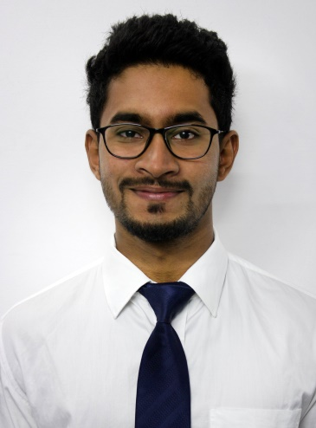
ABHISHEK

Email: abishek.336568@2freemail.com

Objective
To seek challenging assignments and responsibilities, with an opportunity for growth and career advancement with the goal for successful achievements. Also an active, dynamic and hardworking by nature personnel with the ability to learn new tasks faster and implement the same for the organizations growth needs.

Scholastic Credentials
- Bachelors in Commerce (Taxation)- 2014 (1st Division)
(Barkatulla University).

- Masters in Commerce (Marketing) -2016 (1st Division)
(Barkatulla University).

- Chartered Accountancy- Foundation(CPT) – 2011 (Passed)
(The Institute of Chartered Accountants of India).

- Chartered Accountancy- Intermediate (Group 1)- 2013(Passed)
(The Institute of Chartered Accountants of India).

Internship Experiences
- Article Assistant /Audit Assistant.

Sandeep Mukherjee & Associates. (February 2014- January 2016)

On behalf of the firm conducted various and varied audits for different clients and businesses; experiences of which are:

Danik Bhaskar Corp. (Internal Auditor)

- Checking of daily payment vouchers.
- Consultation regarding the proper treatments of payments with respect to accounting principles and tax implications.
- Verification of all Capital Expenditure Payments.
- Auditing of monthly payroll slips of the employees.
- Conducting Attendance audit of the employees.
- Monthly reporting of audit conducted and discrepancies observed and rectified, to the group’s auditing manager.
- Checking of proper calculation of Service Tax liabilities and any TDS liabilities for the organization.
- Also, has gained experience of working on ERP software’s of the organizations.

Reliance Telecommunications.

Provided the services of physically verifying and checking the working conditions of all the equipment’s and parts of the company at their warehouse and declaring a statement regarding the proper maintenance and whereabouts of the equipment.

Sandeep Mukherjee & Associates.

- Provided financial services such as accounting, closing of books and return filing to various clients of the firm.
- Conducted vouching and verifications of the documents produced for audit.
- Has also filed service tax returns of the clients on behalf of the firm.

- Article Assistant /Audit Assistant.

Bhutoria Ganesan & Co. (August 2013- January 2014)

On behalf of the firm conducted various and varied audits for different clients and businesses; experiences of which are:

Deewan Housing Finance Limited. (DHFL)

- Checking of loans sanction & disbursement procedure.
- Verification of Loan documents execution & Closure of loan.
- Checking of Monitoring & storage of post disbursement documents.
- Scrutiny of Expenses.
- Verification of fixed Assets.

National Rural Health Mission. (NRHM)

- Verification of cheque disbursement processes.
- Verification of Hospitals and the maintenance of premises.
- Verification of medicines procured and avoiding any use of expired stock on patients.
- Checking of monitoring & storage of post disbursement documents.
- Scrutiny of Expenses and conducting performance audits on the same.
- Verification of Fixed Assets.
- Physical verification of stock.

Sarva Siksha Abhiyaan. (SSA)

- Verification of books maintained and finding the audit trail of the expenses incurred.
- Verification of expenditure both in respect of capital and revenue.
- Verification of amount received through the central government and the utilization of the same.

System Proficiency
      - E-filing of Income Tax Returns.
      - Basic understanding of MS Office (MS Excel, MS Word, MS PowerPoint) and Tally ERP 9
      - Successfully completed 100 hours of Information Technology Training as per provisions of ICAI.
      - Successfully completed Orientation Program as per the provisions of ICAI.
      - Successfully completed the TALLY ERP 9 course from a recognized coaching institute.

Extra-Curricular Activities & Achievements

Professional:

- Served as a House Captain in school.
- Served as an active volunteer/member/photographer in WWF (World Wide Fund for Nature) Bhopal campaigns. (World Earth Hour and World Wet Land Day)
- Co-founded an Advertising start-up in Bhopal which provides branding solutions to the clients and and event coverage related services, served as the Director of Photography (DOP) in the start-up, the organization was named “Moxie Morons”
Personal:

- Participated in various Adventure sports organized by the CICASA, Bhopal.
- Served as the Convener for Hotel and Stay at National Conclaves held in Bhopal for the year 2014 and 2015.
- Practices photography with many colleagues and clients for better understanding of photography.

Strengths:

- Venture into challenges with positive and systematic approach.
- Determined & Self-Confident.
- Risk Taker and understands the practical approach towards situation.

Personal Information
Date of Birth : 12th November 1993
Marital Status : Single
Hobbies : Photography, Painting, Sketching, Travelling, Swimming.
Languages Known : English, Hindi and Malayalam.
(Read, Write and Speak)

(ABHISHEK)

