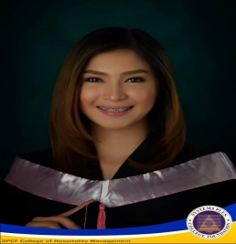
BARBY
BARBY.336580@2freemail.com

Career Objective

To have a position where I could contribute my skills which utilizes high degree of enthusiasm and strong dedication to the total development of work force.

PERSONAL PROFILE:
Date of Birth : April 9, 1994
Place of Birth : Morong Rizal
Civil Status : Single
Height : 5’2
Weight : 98lbs
Citizenship : Filipino

EDUCATIONAL ATTAINMENT

COLLEGE:
Course: BS Tourism Management
S.Y. : 2010 – 2016
School: Systems Plus College Foundation
Address: Balibago Angeles City

WORK EXPERIENCE:
- Company: Royce Hotel and Casino
Address : Ninoy Aquino Ave., Clark Freeport Zone Pampanga
Inclusive Dates: April 26, 2016- present
Position : Membership and Redemption Associate

- Company: Philippine Academy for Aviation Training
Address : Claro M Recto Hwy, Mabalacat, Pampanga
Inclusive Dates: June 2015 – December 2015
Position : Customer Service

- Company: Expert Global Solutions
Address : BC4-BC5 Phil Excel Business Park, Manuel A. Roxas Hwy, Mabalacat
Inclusive Dates: April 2015 – July 2015
Position: Customer Service Representative

- Company: Eaglesky Technology Amusement and Gaming Inc.
Address : Bldg. N7547 E. Andrew St. A Bonifacio Avenue Clark Freeport Zone Clarkfield
Inclusive Dates: February 2014 – June 2014
Position : Production Dealer

5. Company: Ties That Travel
Address : Unit 167, Grd Flr. SM City Clark, M.A Roxas Highway, Angeles City
Inclusive Dates: April 2013 – May 2013
Position : Customer Service

SKILLS:

- Computer Literate
- Knowledgeable in Hospitality Industry
- Willing to stretch extra hours to complete assigned work.
- Ability to work independently
- Goal oriented, has the ability to achieve goal given in a specified time frame

