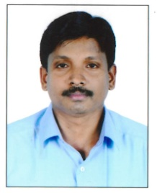
VIJITH

E-Mail: vijith.336623@2freemail.com

Career Objective
To accomplish a significant stature in my passion in Logistics and Supply Chain, utilize my day to day learning and exposure for the organization to achieveat its level best and at the same time to achieve my personal career goals
Career Synopsis

Worked as a warehouse assistant in Fakruddin Group of companies dubai for 5 -Years.

Key Deliverables
- Reporting to Warehouse Team Lead
- Low level put away and picking
- Palletize the pallets load
- Wrapping and labeling the shipping
- Manage the stock inbound and issues to the work shop and work site
- Manage the data base updating
- Prepare the list for re ordering
- Pick the order list from the work shop and the project sites
- Overall managing the operations at the electrical component warehouse
IT Skills

- MS Office
- Windows

Personal Details

Nationality : Indian
Gender : Male
Age & Date of Birth : 05th Sep 1980
Marital Status : Married
Languages : English, Hindi, Malayalam & Tamil
Hobbies : Volly Ball, Music
Visa Status : Visit Visa

Passport Details
Issue Date : 07/01/2013
Expiry date : 06/01/2023
Issue place : Dubai
DECLARATION
I hereby declare that the above mentioned data are true and best of knowledge and belief. If I am appointed, I shall
discharge my duties satisfactorily

VIJITH

