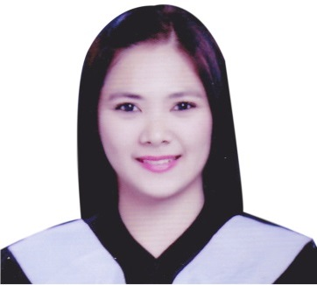

LORENA
Objective |  | To be able to qualify for a position that will utilize my educational qualification, which will serve not only as a career growth but also a challenge to my profession.
SEMINARS/TRAININGS |  | “TESDA TRAINING”  Finishing Course (100hrs)  San Fernando, Pampanga, Philippines  April 1, 2012  “Career Quest 2012”  Job Orientation For Graduating College Students  San Fernando, Pampanga, Philippines  March 27, 2012  “Clark Corex 2011”  Fontana Convention Center  Clark, Pampanga, Philippines  October13-14, 2011
Skills |  | - Technical Skills (MS OFFICE PACKAGE)  - Soft Skills  - Communication  - Inter-Personal Skills  - Impressive and Pleasing Personality  - Positive Attitude
Work History |  | Data ENCODER / SAFER BANK (On Job Training)  A CONSUNJI ST. CITY OF SAN FERNANDO PAMPANGA, PHILIPPINES  (250HRS.) April 18, 2012 - June 8, 2012  - Carries out any lawful and reasonable instruction as instructed by reporting line.  - Ensures that confidentiality of data collected and stored are maintained  - Assures protection of the systems and data by performing at least one system back up per day.  - Assists when and where necessary in developing improved patient records management  - Consults with software programmers and/or evaluators for troubleshooting database problems.  - Maintains accurate and up-to-date data.  - Attends required data entry trainings and meetings and provides input to enhance of data systems.  - Produces automated reports on request.  - Other duties as assigned.  counter checker / MADISON SHOPPING PLAZA INC.  SM CITY PAMPANGA, BRGY. LAGUNDI, MEXICO, PAMPANGA, PHILIPPINES  July 23, 2013 – December 31, 2013  - Count each item to ensure number compliance with work orders and raise concerns about additional or lesser items received.  - Checking number of items on the work order list.  - Compare work orders with actual items to ensure that the proper item and quantity has been pulled.  - Check transactions against cash / credit card payments received and ensure that they tally.  - Validate checks and shady credit or debit card payments and confer with customers to ensure that payment instruments are being used legally.  - Create and maintain counter checking reports and inform supervisors of any outstanding issues regarding missing items or dodgy cash transactions.  PROMODISER / NATIONAL STORE LLC,.  AL NAHDA SHARJAH, DUBAI UAE  April 28, 2014 – November 24, 2015  - Ensures the achievement of sales targets;  - Responsible for timely and proper display and replenishment of merchandise;  - Receives and check accuracy of all products deliveries and reports discrepancies immediately;  - Conduct inventory as scheduled;  - Identify and segregate items for pull-out damage, dirty and slow moving;  - Safeguard merchandise from external and internal losses (e.g. theft, damage, etc.);  - Maintain orderliness and cleanliness at the selling and stockroom area;  - Prepare and submit accurate reports on time;  - Provides fast, efficient and courteous service at all times to customers;
Education |  | BACHELOR OF SCIENCE IN COMPUTER SCIENCE / ST. NICOLAS COLLEGE OF BUSINESS AND TECHNOLOGY / SAN FERNANDO, PAMPANGA, PHILIPPINES  JUNE 2009 – MARCH 2013

I do hereby declare that all the above information furnished by me are true and correct to the best of my knowledge.

