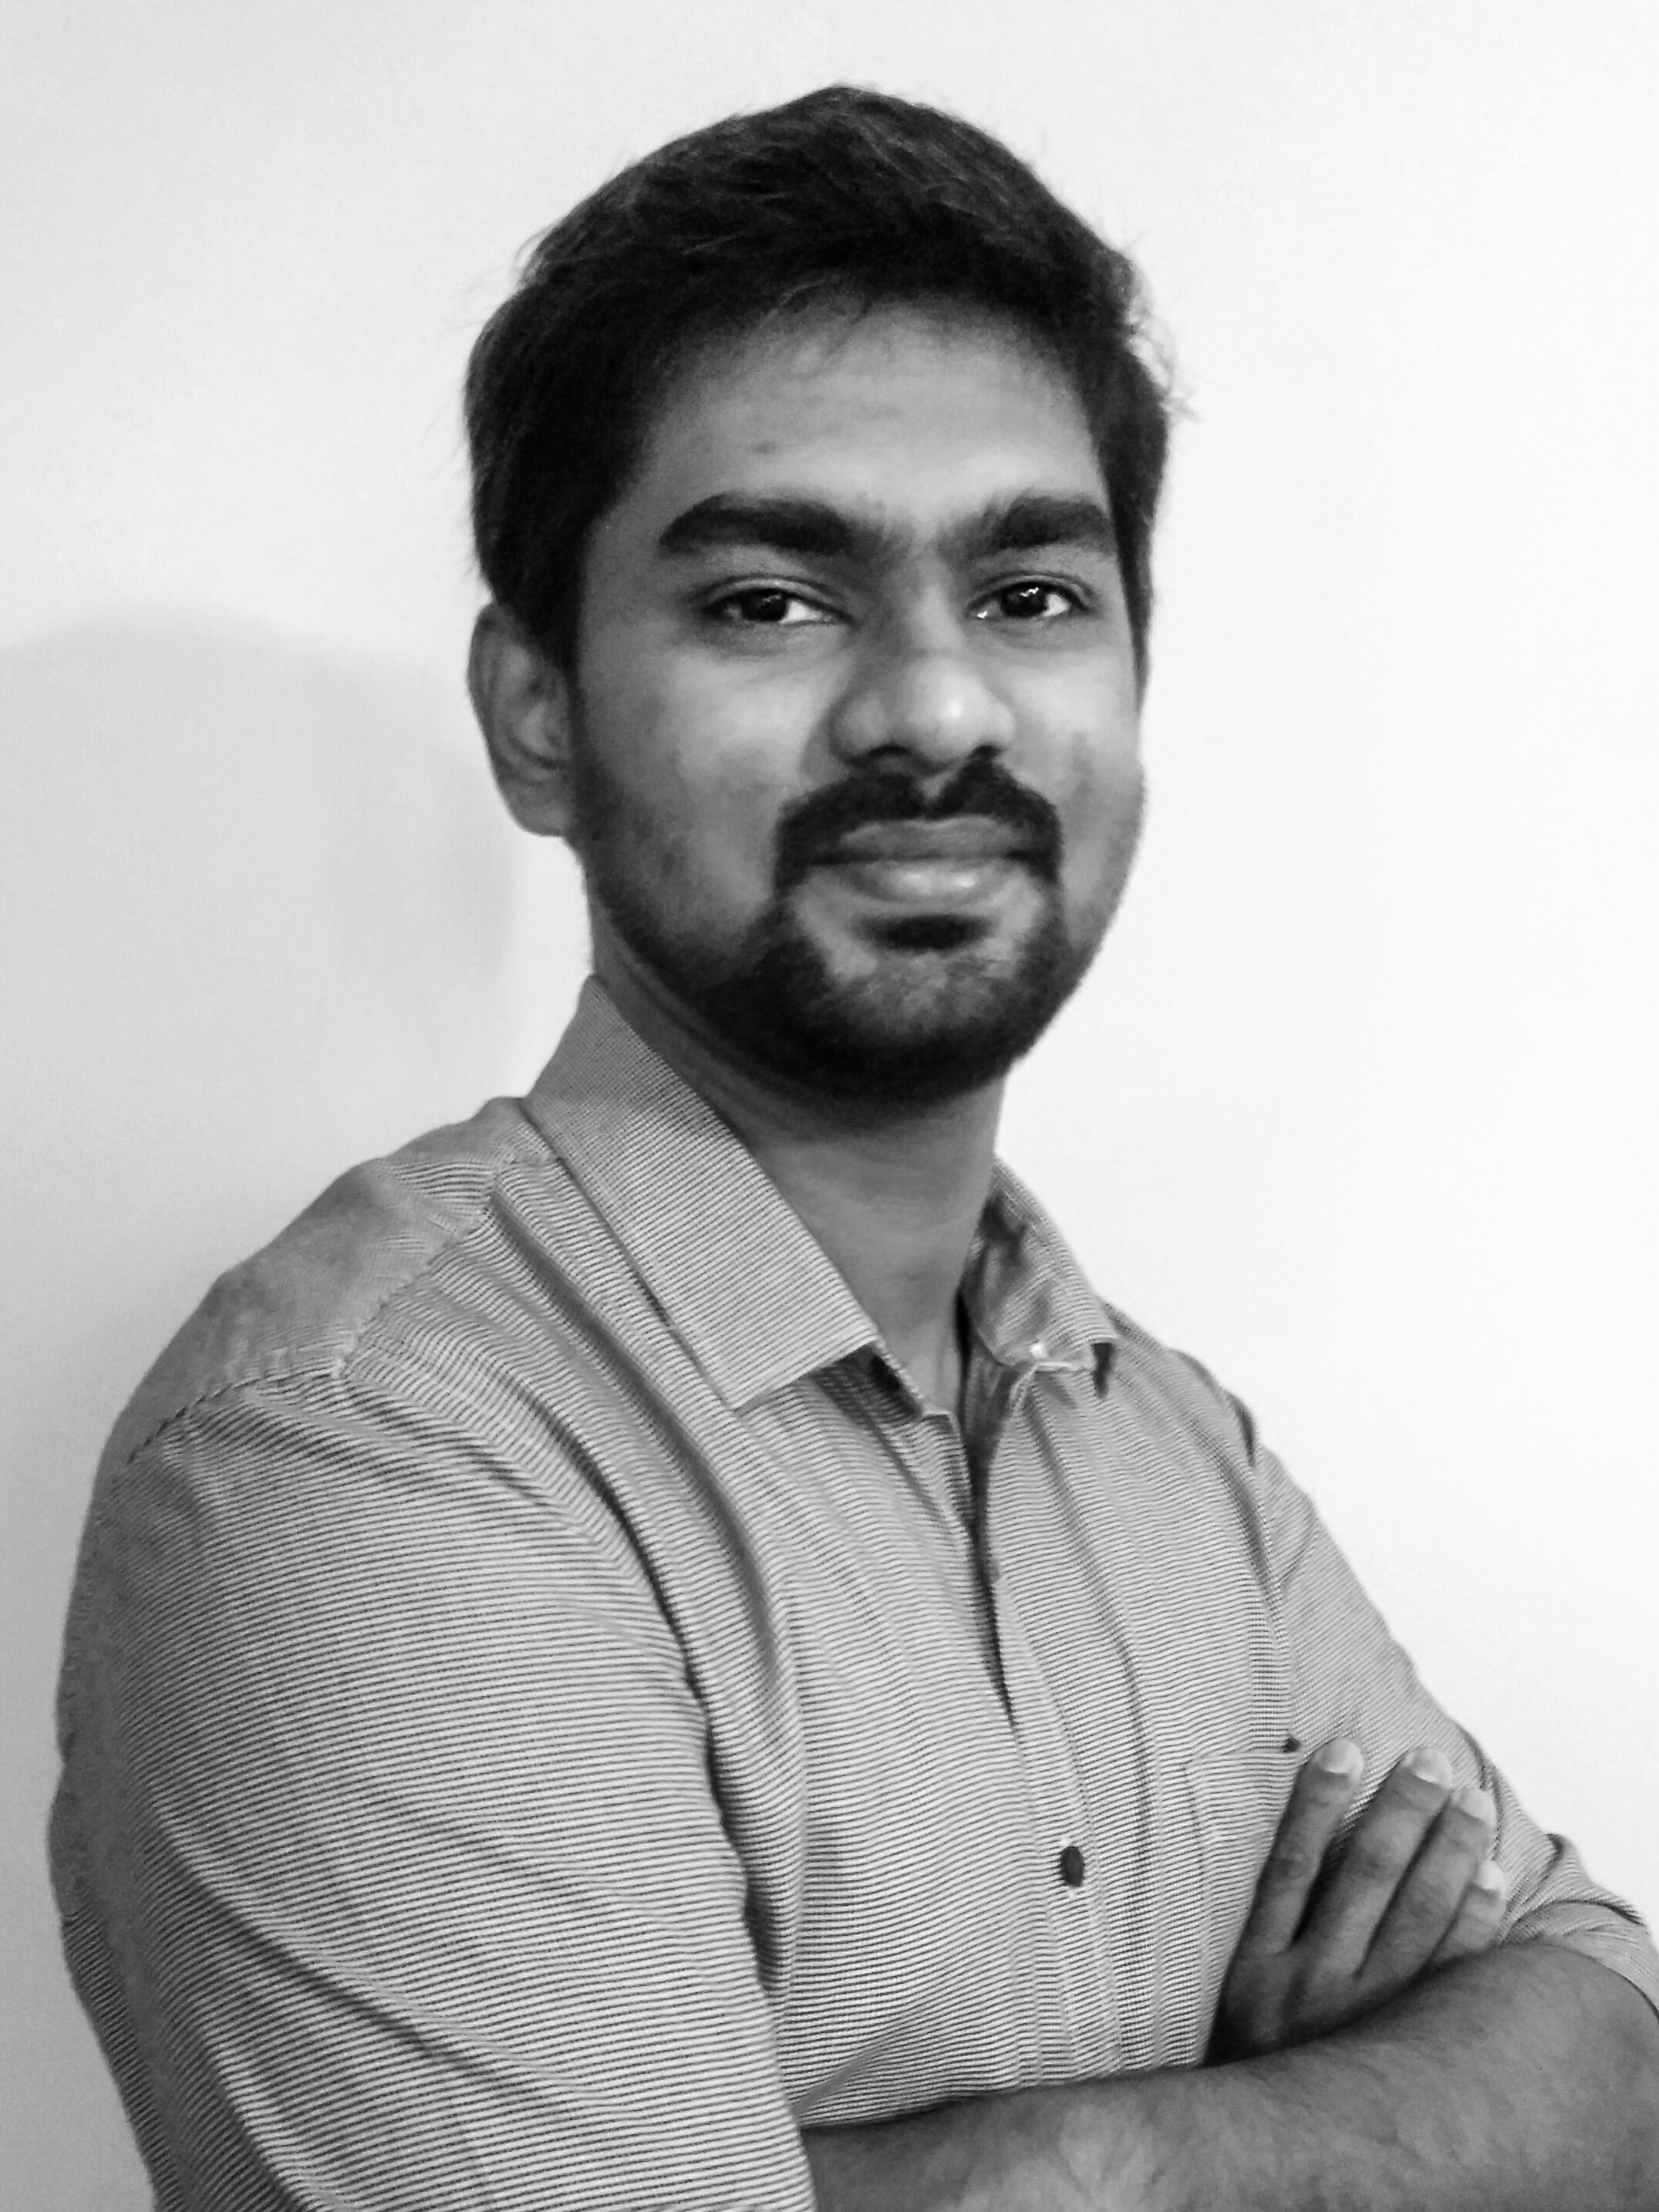
Ijas
ijas.336643@2freemail.com

PERSONAL DETAILS

Age : 29 Yrs Date of Birth : 25/05/1987
Gender : Male Marital Status : Married

EDUCATION
NIMHANS, Bangalore, M. Phil in Psychiatric Social Work (April 2013)

UGC-NET in Social Work (June 2012)

Pondicherry University, Pondicherry, M.S.W. (May 2010)
Specialization: Medical and Psychiatry

Amrita Vishwa Vidyapeetham, Coimbatore, Certificate Programme on Psycho-Social Counselling (December 2009)

University of Calicut, Calicut, B.A. in Sociology (March 2008)

Language Proficiency: Fluent English, Malayalam, Kannada and Tamil.

Computer Skills: Microsoft Office

PROFESSIONAL EXPERIENCE

Psychiatric Social Worker
National Institute of Mental Health and Neurosciences (NIMHANS), Bangalore
March 2014 – Present
- Provided and supervised clinical assessment, psychiatric diagnostic services to adult.
- Supervised and provided psychosocial assessment and tailor made psychosocial interventions at individual, familial and group level.
- Facilitated and supervised group intervention for the caregivers of elderly with psychiatric disorders.
- Provided individual psychotherapeutic intervention for persons with Anxiety and Affective Disorders.
- Provided psychosocial interventions at individual, group and familial level for patients with substance used disorders.
- Conducted home and agency visits.
- Networked with the local social service agencies to rehabilitate the persons with psychiatric disorder.
- Supervised clinical activities of Psychiatric Social Work Trainees in post graduate level.
- Participated in multi-disciplinary team of psychiatrists, psychologists, and psychiatric nurses.

Behavioural Intake Counsellor
PPC Worldwide, Bangalore July 2013 – Feb 2014

- Provided counselling services to employees of MNCs through the technology assisted means such as telephonic, chat and email services.
- Handled networking with the affiliates in providing Employee Assistance Programme.
- Provided in-person therapeutic interventions for employee issues.
- Handled documentation of services by ensuring confidentiality.
- Conducted in-house clinical training and development session for colleagues.

Psychiatric Social Work Trainee
National Institute of Mental Health and Neurosciences (NIMHANS), Bangalore May 2011 - April 2013

- Provided clinical assessment, psychiatric diagnostic services to adult and children.
- Conducted psychosocial assessment and provided tailor made psychosocial interventions at individual, familial and group level.
- Provided psychosocial interventions for children with Mental Retardation, Learning Disabilities, Autism, ADHD and other Behavioural and Emotional Disorders.
- Facilitated group intervention for the parents and family members of children with psychiatric disorders.
- Provided consultation services to couples and families with interpersonal difficulties and sexual problems.
- Provided individual psychotherapeutic intervention for persons with Anxiety and Obsessive Compulsive Disorders and Affective Disorders.
- Provided psychosocial interventions at individual, group and familial level for patients with substance used disorders.
- Provided psychosocial assessment and intervention for patients with various Neurological and Neurosurgical conditions.
- Provided outreach services to local community through Rural Mental Health Centre and home visits.
- Participated in multi-disciplinary team of psychiatrists, psychologists, and psychiatric nurses.

Junior House Officer (Rehabilitation Social Worker)
Richmond Fellowship Society, Bangalore August 2010- April 2011

- Handled the tasks of conducting psychosocial evaluations like assessing patient's mental and physical records as well as gathering demographic information
- Provided social work services to patients with complex psychosocial needs independently as well as with group.
- Handled the responsibilities of providing counselling to patients.
- Evaluated patient at admission and formulated appropriate treatment plan.
- Took a fundamental role in coordinating services with the interdisciplinary team to ensure appropriate patient care.
- Informed and clarified for patients and their families the facility policies and resources.
- Maintained records and prepared reports.

TRAINING AND CONFERENCES

- One Day Workshop on Solution Focused Brief Therapy, CliqueIn Bangalore, Sep 2015.
- 34th ISPSW Annual Conference, Coimbatore, Jan 2015.
- Workshop on Effective Parenting, Dept. of Psychiatric Social Work, NIMHANS, May 2012.
- 30th Annual Conference of Indian Society of Professional Social Work (ISPSW), Jan 2012.
- Training Programme on Professional Development of a Reflective Practitioner, Dept. of Psychiatric Social Work, NIMHANS, Dec 2011.
- National Workshop on Research Methodology in Psychosocial Issues, Dept. of Psychiatric Social Work, NIMHANS, Nov 2011.
- One Day Workshop on Unmet Psychosocial Needs of Trans gender, Dept. of Psychiatric Social Work, NIMHANS, Nov, 2011.
- One Day Person Centred Thinking Skill Course, Institute of Person Centred Approaches in India, Jan 2011.
- Training Programme on Specialized care for Children Affected by Drug Abuse, NIMHANS, Jan 2010.
- International Conference on Autism: Social Skills and Creativity, Dept. Social Work, Pondicherry University, Dec 2009.
- IASSH International Conference on Health, Equity, and Human Rights, Pondicherry University, March 2009.
- CAMHADD International Seminar on HIV/AIDS & Child Development, Aug 2008.

WORKSHOPS CONDUCTED/ORGANIZED
- Co-Organized One Day Workshop on Solution Focused Brief Therapy, NIMHANS, Feb 2016.
- Co-Conducted One Day Workshop on Solution Focused Brief Therapy, Youphoria Calicut, Mar 2016.

FELLOWSHIP

- Maulana Azad National Fellowship 2010-11
PUBLICATIONS AND PRESENTATIONS

- Article – “Solution Focused Approach and Social Work”, Published in The Social Spectrum, Network of Professional Social Workers – India, July 2016.
- Research Paper – “Mental Health Literacy among NSS Programme Officers” Presented in 34th ISPSW Annual Conference, Coimbatore, Jan 2015.
- Concept Paper - “Understanding Mental Health Literacy (MHL)” Presented in 31st ISPSW Annual Conference, Bangalore, Jan 2012.
- Article- “Psychoeducation an Overview” Published in Journal of School Social Work, Dec 2011.
AFFILIATION

- Life Member -Indian Society of Professional Social Work (ISPSW)
- Accredited Member - Association of Solution Focused Practices – India (ASFP-I)
- Richmond Fellowship Society (India), Bangalore

IJAS

