CURRICULUM VITAE
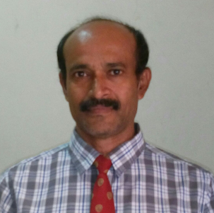

Ashokan
Ashokan.336688@2freemail.com

Career Objective:

As a skilled professional, seeking a challenging position where I can utilize my skills and experiences efficiently to add better values to the organization and to the professional career.

Academic Details:

Graduated in BA Economics & History from Calicut University, Kerala

Professional Experience:

COMPANY WORKED: - Group of Companies
RBK MIDDLE EAST LLC (Reebok Middle East),
RSH MIDDLE EAST LLC (Royal Sporting House)
PROGOLF INTERNATIONAL LLC

From 2002 to 2016 Worked in import department of RSH, RBK and
Customs Clearing Executive.

Duties and Responsibilities:-

Responsible for effectively and proactively managing the documentation team that to ensure for accurate and prompt deliveries were made to both internal and external customers.

- Preparing the import shipment document for custom clearance and checking the documents.
- Giving the proper Customs Tariff Code and matching with shipment documents.
.
- Coordinate the online customs clearing from the office.
- Import issues discussing with Dubai customs such as
Brands, HS code, Duty payment, Short collection, Trade mark Registration and Customs Inspection etc.

Work Experience.

Sales Supervisor:-

- Four years experience as a Sales Supervisor in Sport Station Golf house,
Studio R (recently known as Stadium) under RSH MIDDLE EAST
LLC (1997 to 2002)
DRIVING LICENSE

- Holding valid U.A.E Driving License

Various services through Dubai trade and its enabled applications.
- Import / export documentation.
- Claims and refunds.
- Import codes / representative cards.

Key Skills:
- Comprehensive knowledge of logistical procedures & process.
- Handling import/export shipments.
- Ensure proper co-ordination with the clients.
- Track & Trace of both air and sea shipments.
- Set procedures and coordinated remotely with the third party.
- Updating the clients regarding the status of the consignments.
- Knowledge of Mirsal -2 and documentation process of Dubai customs.
- Forged and maintained professional relationship with service providers.

Personal Skills:
- Adaptability to new concepts & responsibilities.
- Excellent Communication Skills & Interpersonal Skills.
- Function Independently as well as a team member.
- Quick Learner.

Language knows:
- English, Hindi, Malayalam&Tamil

Visa Status:

- Residence Visa under RSH Middle East LLC

Personal Details:

Nationality : Indian
Date of Birth : 02/12/1960
Sex : Male
Marital Status : Married

Declaration:

I hereby declare that the above mentioned particulars are true and correct in my
Knowledge and belief.

