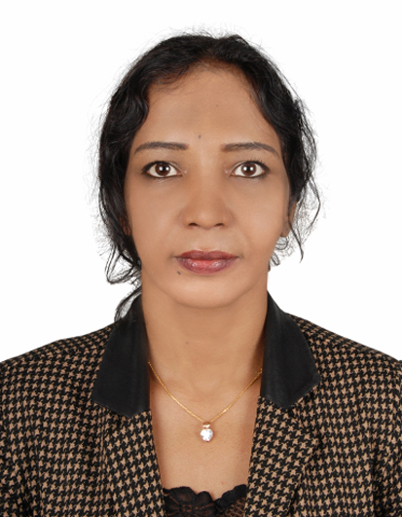

Wegdan

Sharjah -Alqassima.
E-mail: wegdan.336705@2freemail.com
Education
- 2002: B.A. Business Administration – Alneelin University, Faculty of Commerce and Economy, Sudan.
- 2012: Professional Diploma from European Institute for Business Managers in Crises Management & Professional Management, Kuala Lumpur, Malaysia
- 2013: Professional Diploma from American Instituted in Marketing & Sales
Management, Istanbul, Turkey
- 2014: Excellent, Award Leadership in Management from American Instituted, Istanbul, Turkey

Languages Known:

Arabic – Mother tongue

English – Bilingual

French – Communications
Career Objective
5 years’ experience in developing and executing marketing strategies with the unique ability to understand the ongoing market scenarios and customers trends using exceptional marketing communication skills, including but not limited to:
- Strategic planning and leadership.
- Decisive: Capable of delivering quick solutions to the marketing challenges.
- Extensive work with all sources of media channels.
- Result oriented: Ability to achieve target within given time
Personal Qualities
- Initiative
- Interpersonal,
- Engagement
- Strategic Planning.
- Stress Tolerance

Skills
- New Business Development
- P&L Management
- Strategic Planning
- Operations Management
- Key Account Management
- Turnaround & High-Growth Strategies
- Customer Relationship Management
- Staff Training & Development
- Contract Negotiations
- Budgeting & Forecasting.
Professional Experience
Marketing &Sales Manager Sur International Turkish Company, Sudan Branch, 2014 to 2016.
Key Responsibility:
-Designed annual marketing plans to achieve the organizational goals and monitored the implementation of marketing strategies.
Marketing Activities:
- Managed entire product marketing cycle – Planning and applying the use of various sales strategies.
- Managed the budget of the marketing department.
- Initiated and coordinated advertising campaigns and promotional activities.
- Controlled all aspects of production line.
Market Research:
Conducting frequent surveys among the customers regarding the requirements of products at present and estimating the requirements in the future. Analyzed current market trend and competitor information.
Marketing Manager RD&SN Kuwait Alrashed Alsinan Real state/ Malaysia 2011– 2013
Key achievements:
Developed marketing communication strategies for the launching process of new Products and the branding of existing products.
Marketing Activities:
- Prepared the pricing strategy of the product.
- Interacted with media for promotion of the product – Made key messages to attract the customer towards the brand name.
- Selected special products to be displayed at promotional events and exhibitions.
- Negotiated with the suppliers and vendors regarding distribution contracts.
- Maintained cordial relationships with the stake holders and shareholders of the company.
Achievements
- Reduce the marketing budget by 2% by proper planning.
- Successfully achieve targets in six consecutive months.
Event Coordinatorfor Touristic & Real-estate, Sudan Branch 2008 -2012
Key achievements:
Introduce a marketing campaign that brought in many corporate customers
• Plan and execute successful events for individuals and corporate clients
• Ensure material and manpower is available for any events in progress
• Advise clients on setup options
• Provide clients with estimates on cost of events
• Maintain liaison with caterers and managers.
Event Assistant Riw Albrier trading company, Sudan 2004 -2008
• Timely collected, maintained and delivered event and equipment materials which resulted a decrease in customer complaints from 20 to less than five complaints per month
• Entered event information through scheduling database that greatly enhanced efficiency
• Represented company on the telephone and at events
• Met, greeted and directed guests
• Set-up table, linen and decorations
• Designed, created, distributed and removed event signage

