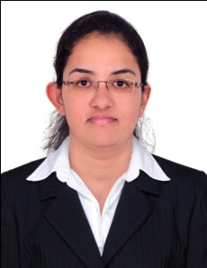
MISHA
MISHA.336708@2freemail.com

Career Objective:
Seeking a position in your esteemed organization that gives me the scope to enrich my knowledge and skills with continual learning and professional growth.

Academic Chronicle:
- Bachelor of Medical Radiological Technology
University College of Medical Education under Mahatma Gandhi University, Kottayam Kerala (2009-2013)
- Twelfth Grade
Mar Dionysius School and Junior College
Percentage: 70%. (2008-2009)
- Tenth Grade
Carmel Convent School and Junior College
Percentage: 86%. (2006-2007)
Work Experience:
- Worked in HCG CANCER SPECIALITY AND RESEARCH CENTRE,BANGALORE
for 2 years
Administrator Skills:
- Well organized and able to prioritize work in an efficient manner.
- Providing high quality customer service.
- Good level of numeracy.
- Good at juggling tasks and prioritizing.
- Impeccable telephone manners.
- Resolving and managing queries to closure.
Secretarial Duties Technical Ability:
- Microsoft Office Word, Microsoft Office Excel, Microsoft Office Power Point.
- Internet Browsing

Interpersonal Skills:

- Dynamic performer under stressful conditions and strong interpersonal skills.
- Flexible in working environments and willing to adapt and change.
- Efficient in multitasking and doing works independently.
- Capable to understand and solve problems.
- Calm and composed under pressure and able to work to tight deadlines.
- Ability to work within a busy and demanding team environment.
- Able to work with minimum amount of supervision and on own initiative.

Personal Details:

NAME : MISHA
DATE OF BIRTH : 10/04/1991
GENDER : FEMALE
NATIONALITY : INDIAN
LANGUAGES KNOWN : ENGLISH,HINDI,MALAYALAM, AND TAMIL

Declaration:

I do declare that the above information is factual to the best of my knowledge. If given an opportunity, I assure to do my best of abilities in your esteemed organization

