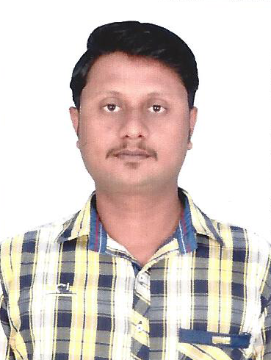
Resume:-
MOHAMED D.Com.Eng
MOHAMED.336728@2freemail.com
-

Career Object:-
I aspire to obtain the position of an Engineering Technician in a company where I can offer my 5 years of experience in the electrical/electronic/cctv and Telecommunication industry in Airtel broadband & Fixed Line with a strong hold in areas such as developing a prototype machine, quality control, systems & Modem –Router installation, and client relations, to complete the projects assigned to me with the maximum efficiency. Document controller. In Emirates Development Industrial Co.Ltd

To achieve the organization aspiration through hard work and dedication in the challenging field of power
Summary
I have more than 5 years of experience as an Electrical And Electronics-Telecommunication which includes 5 years’ experience in India
CCTV-NETWORKING:-Al-Arabia Computer Trading L.L.C (Alain) 1 Year Workink in (UAE)
Document controller. In Emirates Development Industrial Co.Ltd. At ADNOC Helth Club Abudhabi (UAE)
Education & Qualification:-
Year of Passing | Qualification | Institution | Board | Percentage
2008 | D.Com Engg | Muthiah Poly Technical College | Dote | 69%
2004 | SSLC | Government Higher Secontry School | State Board | 60%
2006 | DCA | Diploma in Computer Application | DOTE | “A”Grade

Computer Knowledge:-
- MS Office : Word, Excel, Power point.
- Networking Administration
- Data Entry Operator
- Computer Hardware
- Tally(6.0)
- Ms Windows
- Word 2002
- Excel 2002- Power point 2002
- OOPS Using C++
- C Language
- Html Frond page
Additional Qualification:-
- DCA : Diploma in Computer Application
- Electrician: As I Worked With One Year Electrical Dept.
- Driving Licence: State of qatar
Working Experience:
- As I worked with "Airtel broad band” and telephone technician. In Chennai Bharti Airtel – From 2010 to 2015
- As I Worked with “DOCUMENT CONTROLLER” in Emirates development Industrial company “EDICO”Project with “ADNOC” Helth club Abudhabi
Roles Include
Telephone broadband network administrator.
* "RJ45" connect in Switch & configure IP Dynamic
* Broadband Network Installation.
* Copper value chick using modem page
* Copper wire pair changing.
* DB fault attend
* DLINK. CISCO.BEETELL.BELKIN.TPLINK.DENDA.N150 (OR) N300 modem & Router wifi installation and
* Installation and maintenance EBPX and Intercom,
* Net work creation From ICRM Software
* Tele Calling Coordination.
* Telephone Fault Attend
* Telephone fixed line installation.
As I worked with computer hardware trouble shoot in “CSC“Computer College. Duration from (DEC 2008 to jun 2008 dec)
- Routine inspection of Fire alarm, gas detection system, and all the Fire Safety Equipment
- Building management systems monitoring
- Preventive & corrective maintenance Of CCTV, Access Control, BIO metric
- Audio and video systems, installation and maintenance
- Document Controller: ADNOC Heath Club At Khalithiya Abudhabi(UAE)
- All Document Incoming & outgoing Save and Secure the System,
- Transmitted Entry And DTF Controller,
- MVR Material Verification Record Verified Document and MRO Making Document,
- MRV Material Receipt Voucher Check list Controller,
- Time Keeping And Daily-monthly Site Activities Report in Site Activities,
- Temperature note daily site using At Temp Machine, DC prepare ,
- All Audit Department And Excellent Answer And Sure Document Sowing Controlled the System,
Passport Details:-
Date of Issue : 02-09-2008
Date of Expiry : 01-09-2018
Place of Issue : Trichy.
Personnal Inforamation:-
Date of Birth : 01-06-1986
Marital Status : single
Nationality : Indian
Language Known : Arabic, Tamil, English, Hindi.
Declaration
I hereby declare that the above information is true to the best of my knowledge and belief. I assure that, if I am selected, I will work for the entire satisfaction and improvement of the organization.

