Mohamed
Mohamed.336756@2freemail.com

Creative Web Developer / Front End Engineer / UI Developer / UX Designer

Career Objective

I am seeking a position within an organization or design firm in Web Development, Front End Development, User Experience (UX) and/or Interaction Design (IxD).

I would like to work together with software or web design/develop-ment firms, communicating application design principles and strate-gies for ongoing development.

My aim is to create better experiences for the user, making the web sites / applications and technology easier for the user.

Simplifying communication barriers by bridging the gap between end-users, designers and developers.

Professional Summary

8 Years of experience in all stages of Web and Software development lifecycle, from concept to design and development through quality assurance and tuning.

Highly versed in Web 2.0 concepts with skills in creating websites with RSS, social networking, games, and media capabilities.

In-depth understanding of security, SEO, and optimization to maximize the performance.

Extensive knowledge and on-hands experience in information architec-ture, web design, web development, project management, and testing.

Proven background in large-scale enterprise application implementa-tions. Superior communication, analytical, and interpersonal skills.

Cover Letter

With a BS degree in Comput-er Science, I have a full understanding of the full life cycle of Web Development, Front End Development, User Experience and User Interface.

I also have experience in learning and excelling at new technologies as needed.

Please see my resume for additional information on my experience.

Sincerely,

Mohamed

Mohamed

Creative Web Developer / Front End Engineer / UI Developer / UX Designer

WORK Experience

Senior Web Developer / Front End Engineer / UI Developer & UX

Designer / 2016 - Now

Madcom - Marketing and Advertising.

Responsibilities :

Analyzing the business requirements and defining the overall scope of the project.

Organizing Software Requirement Specification by coordinating with the client.

Analyzing the existing time complexity involved in module and providing a design to improve the performance as well as code readability.

Team Code Review.

Defines site/app objectives by analyzing user requirements, envisioning system features and functionalities.

Designs and develops user interfaces to Internet/intranet websites/applications by setting expectations and features priorities throughout development life cycle, determining design methodologies and tool sets, completing programming using languages and software products, designing and conducting tests.

Recommends system solutions by comparing advantages and disadvantages of custom development and purchase alternatives.

Integrates applications by designing database architecture and server scripting, studying and establishing connectivity with network systems, search engines, and information servers.

Creates multimedia applications by using authoring tools.

Completes applications development by coordinating requirements, schedules, and activities, contributing to team meetings, troubleshooting development and production problems across multiple environments and operating platforms.

Supports users by developing documentation and assistance tools.

Updates job knowledge by researching new internet/intranet technologies and software products, participating in educational opportunities, reading professional publications.

Enhances organization reputation by accepting ownership for accomplishing new and different requests, exploring opportunities to add value to job accomplishments.

Supports and develops web sites/applications developers by providing advice and coaching.

Technology used:

Graphic Design and Web Development

HTML, CSS, LESS, SASS, JQuery, JavaScript, PHP, MySQL, AJAX, CMS, Illustrator, InDesign, Photoshop, Dreamweaver

Computer Skills
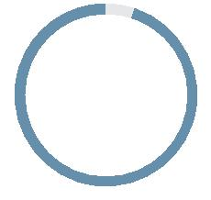

HTML
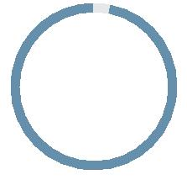

CSS
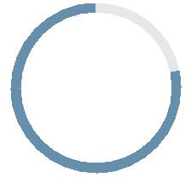

JavaScript
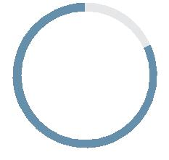

PHP
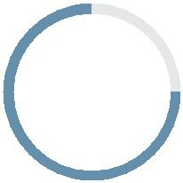

Illustrator
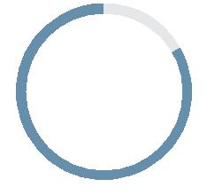

InDesign

Photoshop
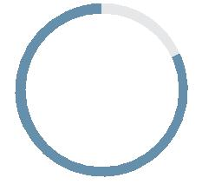

Dream

weaver

Mohamed Mostafa

Creative Web Developer / Front End Engineer / UI Developer / UX Designer

WORK Experience

Senior Web Developer / Front End Engineer / UI Developer & UX

Designer / 2013 - 2016

InterMark-gsw Türkiye - Marketing and Advertising / Consulting

Responsibilities :

Providing accurate timing estimates on work.

Contributing to documentation (instructional and technical specification).

Train other non-technical staff particularly designers.

Contributing to the company development standards working closely with the Head of Development or Technical Director.

Maintaining a high awareness of industry issues and trends, particularly in regard to accessibility, usability, and emerging technologies, and keep team members informed as appropriate, with a view to incorporating these in future projects and staying ahead of the market.

Constantly seeking to self-development by learning new technologies and keeping abreast of markets developments.

Work in an agile development environment by designing, implementing, and testing UI / UX Front End related features for different web and cloud websites/applications.

Continuous quality and speed improvements of existing web and cloud applications with focus on great User Experience across Browsers / platforms.

Work in a team to define, build, extend and design the UI & UX frameworks / standards / design and style guides for existing and new modules of Company Platform.

Provide and continuously improve UI/UX frameworks used from several Teams based on their feedback and needs.

Elaborate requirements together with stakeholders, create mockups, wireframes, rapid prototypes, proof of concepts for product owners and customers to promote and optimize user experience, ease of use and product interaction.

Coach and interact with developers through UI / UX reviews to close the gap between graphic design and technical implementation.

Create rich interactive content.

Experience integrating with server-side code to produce dynamic pages.

Excitement about emerging web technologies.

Experience working with version control systems.

Technology used:

Graphic Design and Web Development

HTML, CSS, LESS, SASS, JQuery, JavaScript, PHP, MySQL, AJAX, CMS, Illustrator, InDesign, Photoshop, Dreamweaver

Computer Skills

HTML

CSS

JavaScript

PHP

Illustrator

InDesign

Photoshop

Dream

weaver

Mohamed Mostafa

Creative Web Developer / Front End Engineer / UI Developer / UX Designer

WORK Experience

Front End Engineer / UI Developer & UX Designer / 2009 - 2013

EGYWEB - Digital Media

Responsibilities :

Providing accurate timing estimates on work.

Contributing to the company development standards working closely with the Head of Development or Technical Director.

Translate concepts into wireframes and mockups that lead to intuitive user experiences.

Facilitate client’s product visions by researching, conceiving, wire framing, sketching, prototyping, and mocking up user experiences for digital products.

Make strategic design and user-experience decisions related to core, and new, functions and features.

Create Web application front end as per design comps and information architecture.

Follow best practices and standards for accessibility and cross-browser compatibility.

Keep current with the latest trends and best practices of UI/UX design and HCI (human-computer interaction).

knowledge of Search Engine Optimization (SEO) to develop search-friendly websites and interfaces.

Create rich interactive content.

Experience integrating with server-side code to produce dynamic pages.

Excitement about emerging web technologies.

Experience working with version control systems.

Technology used:

Graphic Design and Web Development

HTML, CSS, LESS, SASS, JQuery, JavaScript, PHP, MySQL, AJAX, CMS, Illustrator, InDesign, Photoshop, Dreamweaver

Computer Skills

HTML

CSS

JavaScript

PHP

Illustrator

InDesign

Photoshop

Dream

weaver

Mohamed

Creative Web Developer / Front End Engineer / UI Developer / UX Designer

EDUCATION

B.Sc in Computers Science and Software Engineering / 2004 - 2008

Future University - Grade : Good.

Graduation Project - Foundation Management System. (FMS),

UX, UI, Database, Network - Grade : Very Good.

Computer Skills

Graphic Design and Web Development

HTML | CSS | LESS
SASS | JQuery | JavaScript
PHP | MySQL | AJAX
CMS | Illustrator | InDesign
Photoshop | Dreamweaver

INTERESTS

Swimming, Photography, Reading, Painting, Tennis, Camping, Travel

Personal skills

Analytical Skills

Communication Skills

Time Management Skills

Languages

English

Arabic

Mohamed
Creative Web Developer / Front End Engineer / UI Developer / UX Designer

