SHANTHI
SHANTHI.336864@2freemail.com 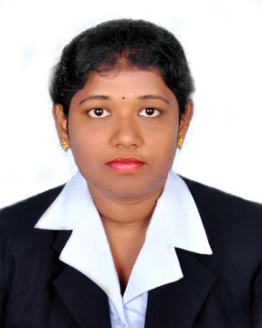

CAREER OBJECTIVE:
To live honest and hard life to work in a highly challenging competitive environment for the enhancement of my creative abilities and optimum profitability of the organization.

PROFESSIONAL QUALIFICATION:
- Completed 2 – Year Degree in Master of Business Administration with 73% from P.S.R. Engineering College, Sivakasi(2012- 14)

- Completed 3 – Year Degree in Bachelor of Business Administration with 59% from Ayya Nadar Janaki Ammal College, Sivakasi(2009- 12)

JOB PROFILE:
Worked as a Assistant HR in Sripathi Paper and Boards Pvt. Ltd., Sivakasi.
(Period from Aug 14 to Oct 15)

JOB DESCRIPTION:
- Preparation of Payroll for workers and staffs( including PF, ESI, GRADUITY)
- Preparation of OT
- Checking and Maintaining the attendance for workers and staff everyday.
- Everyday signature of the employee job card.

PROJECT WORK:
- Summer Project : A Study On Customers’ Satisfaction Level Towards
Products and Service at Sri Balaji Super Market, Sivakasi

- Main Project : A Study On Employees’ Opinion Towards Effectiveness of
Performance Appraisal System in Sripathi Paper and Boards (P) Ltd.,
Sivakasi.

EVENTS AND WORKSHOPS:
- Studied Certificate Course in Export Management
- Attended workshop in V.V. V college for women on the topic of “Research Methodology”
- Participated in “Stress Management and Leadership programs” in ANJA College
- Attended workshop in “Personality Development” V.V. V college for women
- Attended workshop on “Higher Education and Entrepreneurship” in P.S.R Engineering College
- Participated Madras Management Association Student Chapter workshop on “Presentation Skills” in P.S.R Engineering College
- Participated of “Dumb Charade” in Nadar Saraswathi College of Arts and Science

AREA OF INTEREST:
- HR, Admin

TECHNICAL SKILLS:
- Working knowledge of MS-WORD, EXCEL, POWER POINT.
- Basic Operating System : WINDOWS 7, WINDOWS 8 and WINDOWS 10.

PERSONAL SKILLS:
- Very enthusiastic and quick learner
- Confident to work
- Easy to adopt any kind of environment.

PERSONAL DETAILS:
- Date of Birth : 10.04.1992
- Languages Known : English & Tamil
- Hobbies : Searching web, Watching Tv.

DECLARATION:
I honestly declare that the above mentioned details are true to the best of my knowledge.

